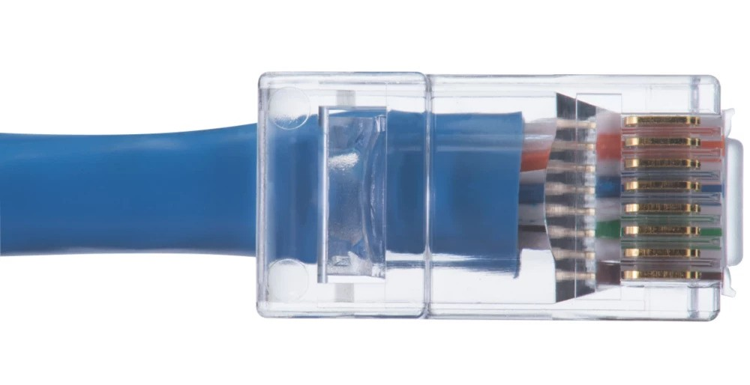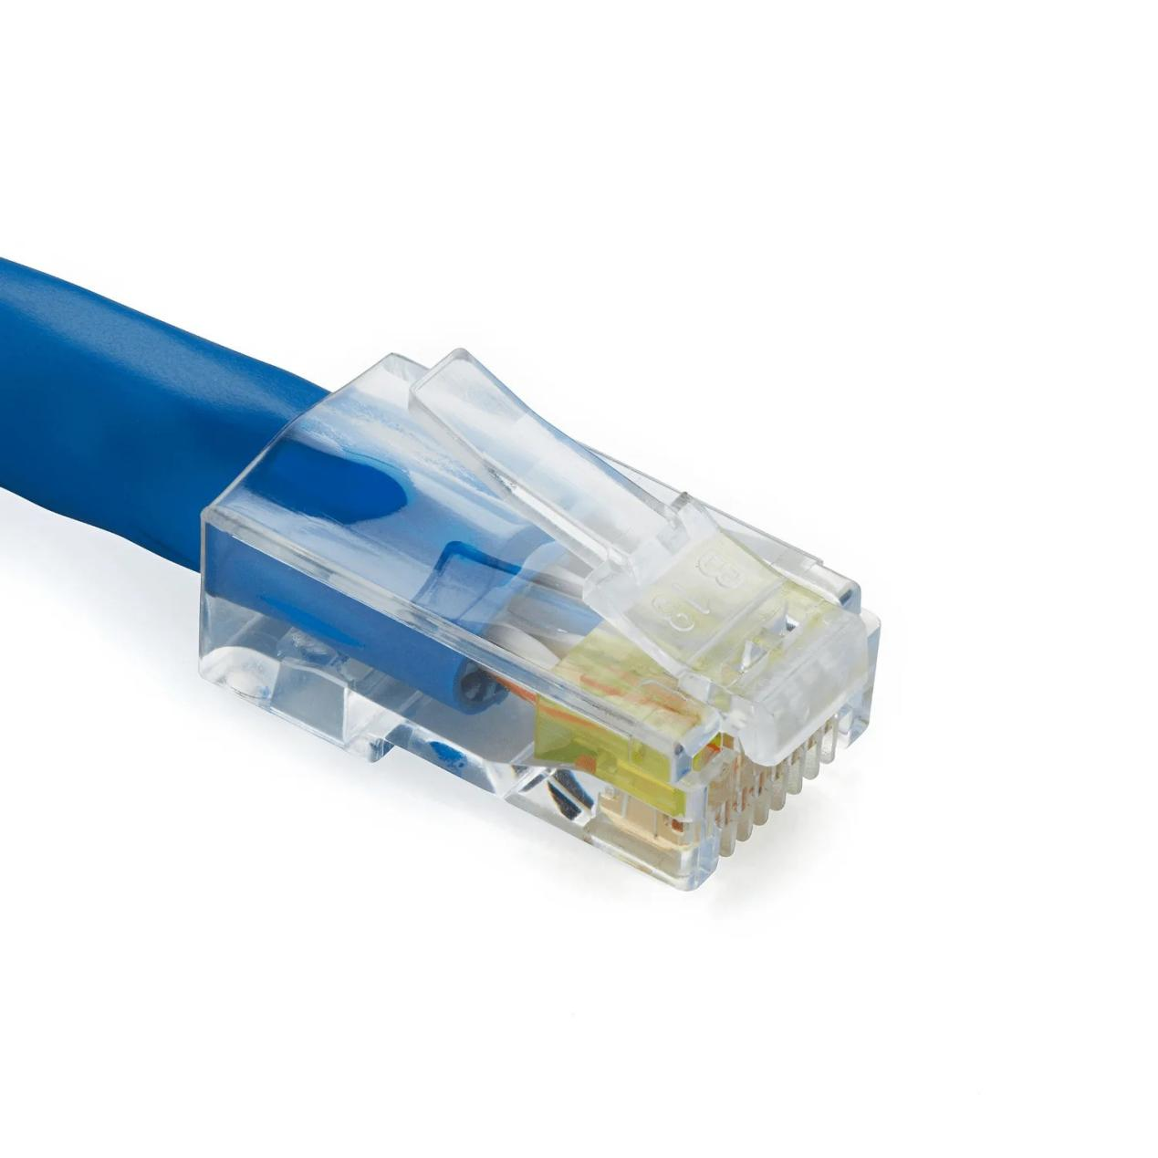

**Cisco packet tracer download:**

1. Visit the official website of [Netacad](https://www.netacad.com/" \t "https://www.geeksforgeeks.org/how-to-install-cisco-packet-tracer-on-windows/_blank) using any web browser &  Press the login button and select log In option. 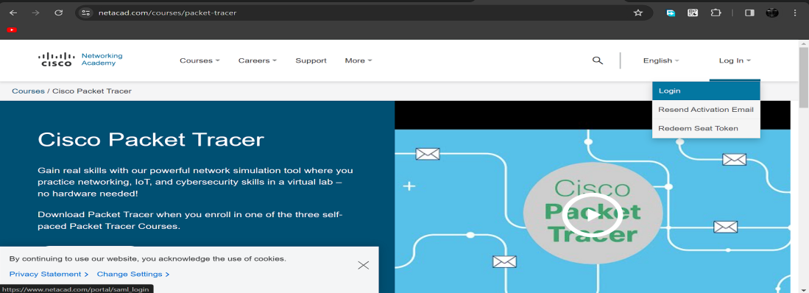
2. Next screen will appear, click on the sign-up option. 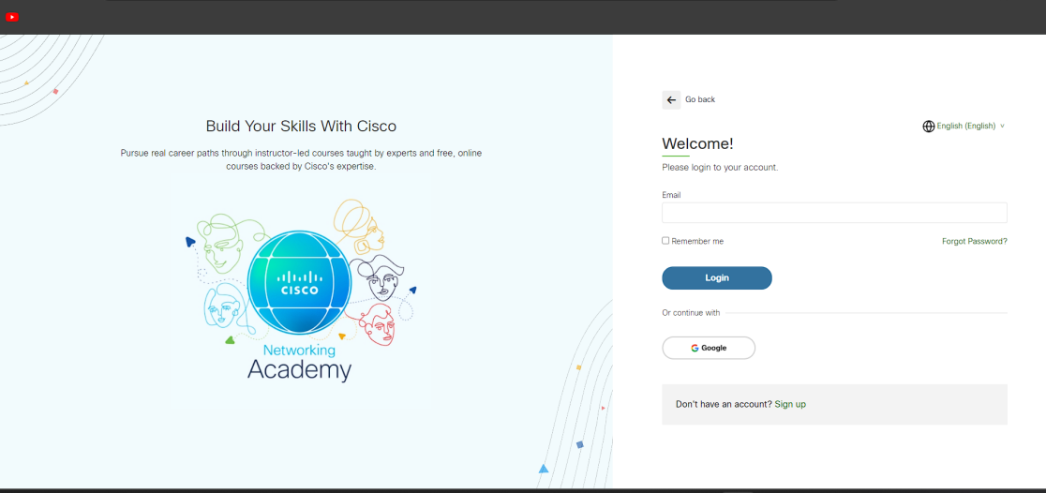
3. Next screen will appear and will ask for email and password and other simple details, fill them and click on Register. 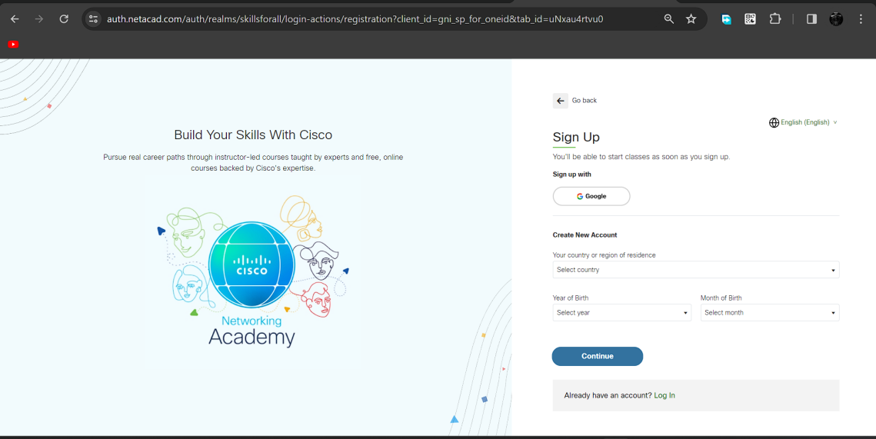
4. Now the login screen appears again so fill in the Email id & On the next screen enter the password and press the Login button. 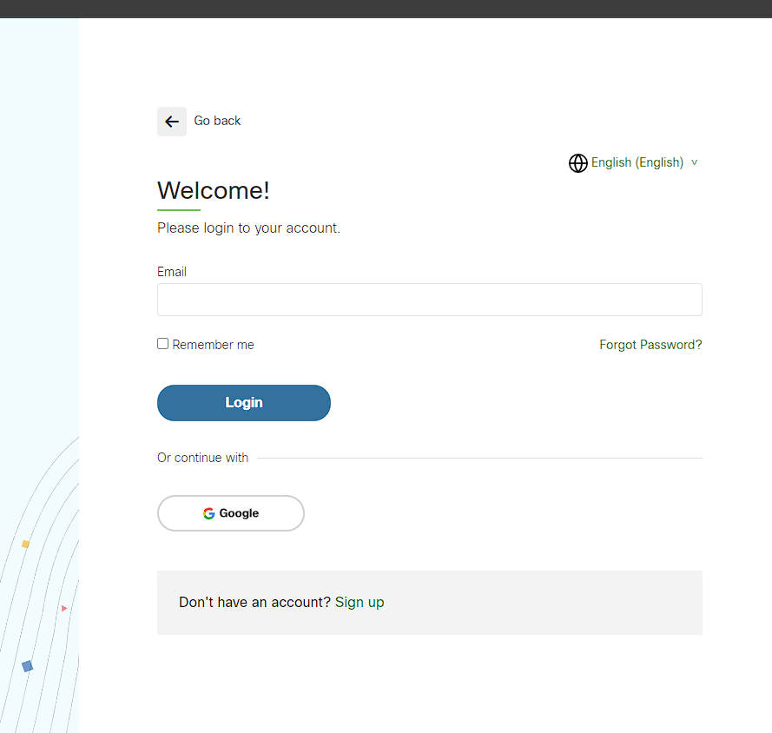
5. Dashboard will initialize, now click on Resources and choose Download Packet Tracer Option.  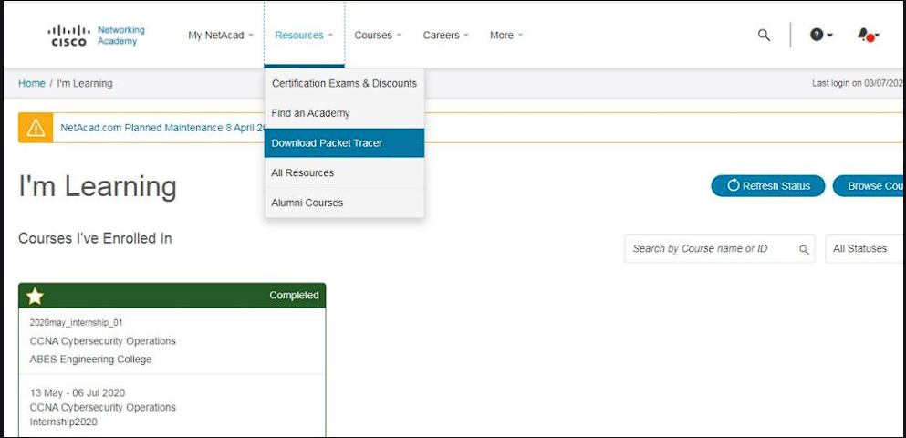
6. On the next web page choose the operating system to download the packet tracer. Downloading will start automatically.

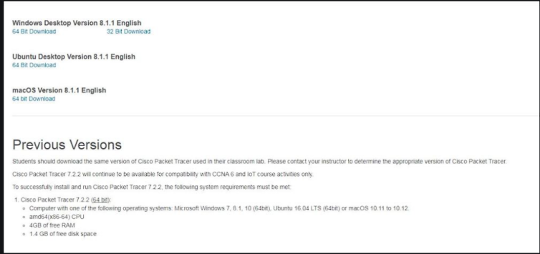

1. Check for the executable file in your system and run it. Next screen is of License Agreement so Click on I accept the license.

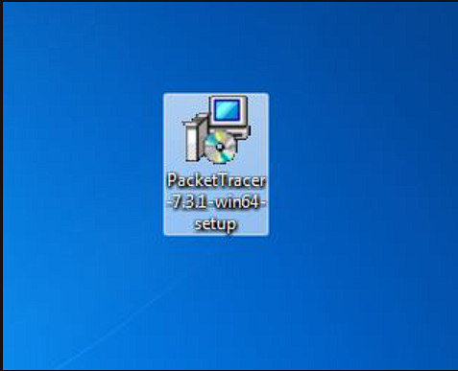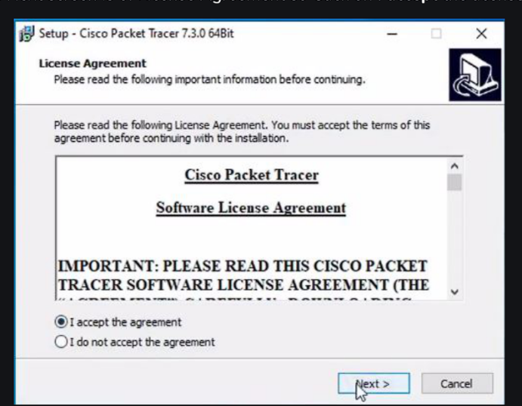

1. Choose the installing location which has sufficient space. 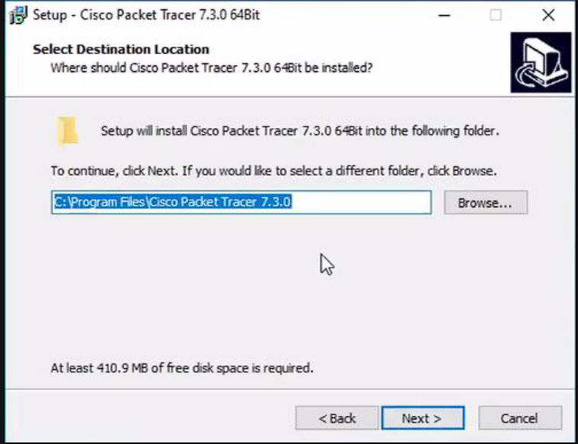
2. Select the start menu folder and click the Next button 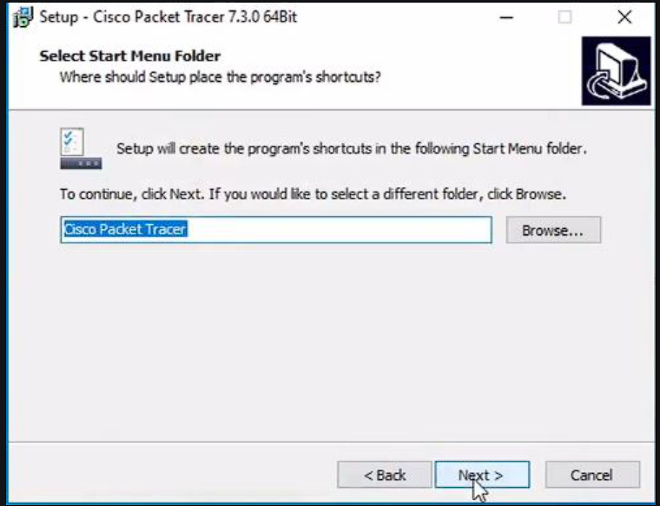
3. Check the box for creating a desktop icon and click on the Next button. 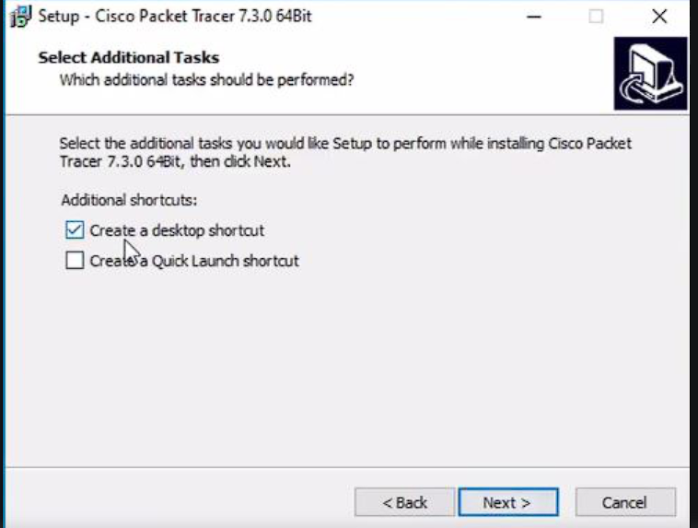
4. Now packet tracer is ready to install so click on the Install button

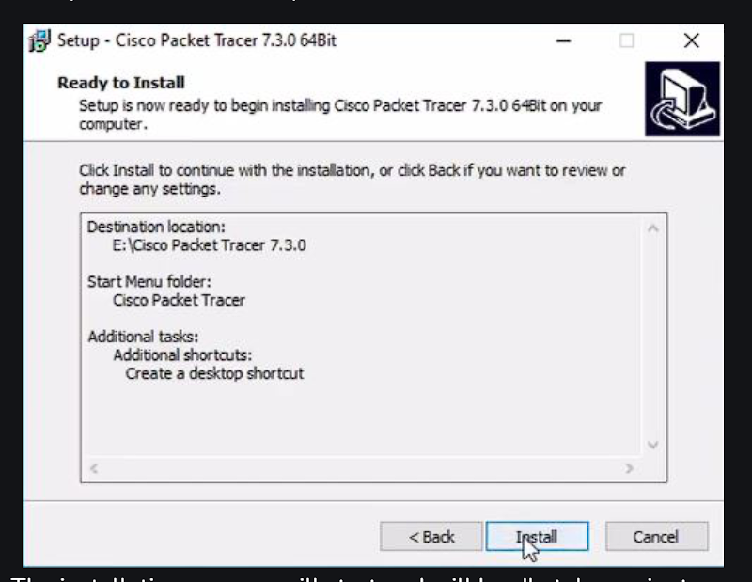

1. After the installation is completed click on the Finish button to complete the installation. 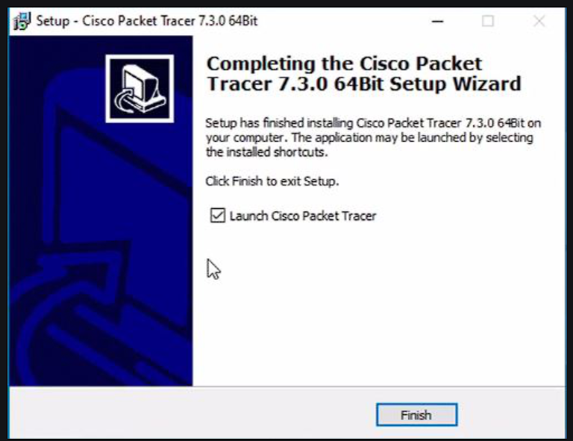
2. Interface is initialized and the software is ready to use.

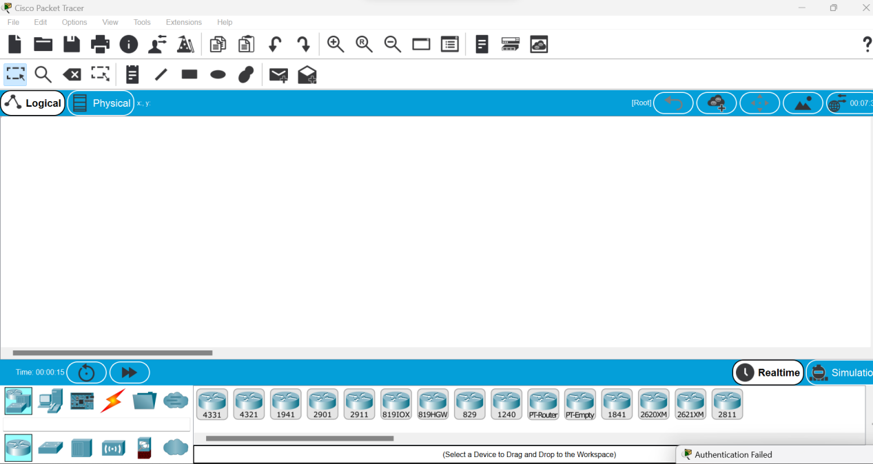

**Implement the uses of subnet masks(static IP-design) with a switch and two end devices.**

* Start
* Take two host and a switch for network connection between them
* Connect them using connecting wire
* Configure IP statically of one end devices.
* Enter the class-c ip address at Pv4 and sub-net it making only 2 valid host(/30)
* Pass the message packet from one end device to other end device.
* Ping any one device ip address using command prompt
* End.

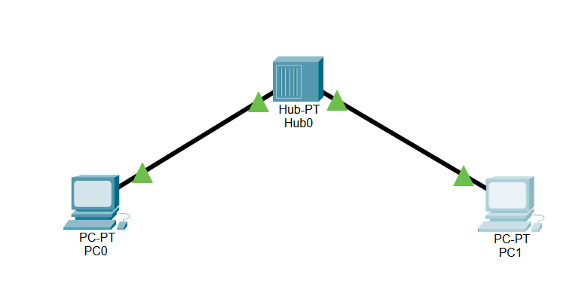

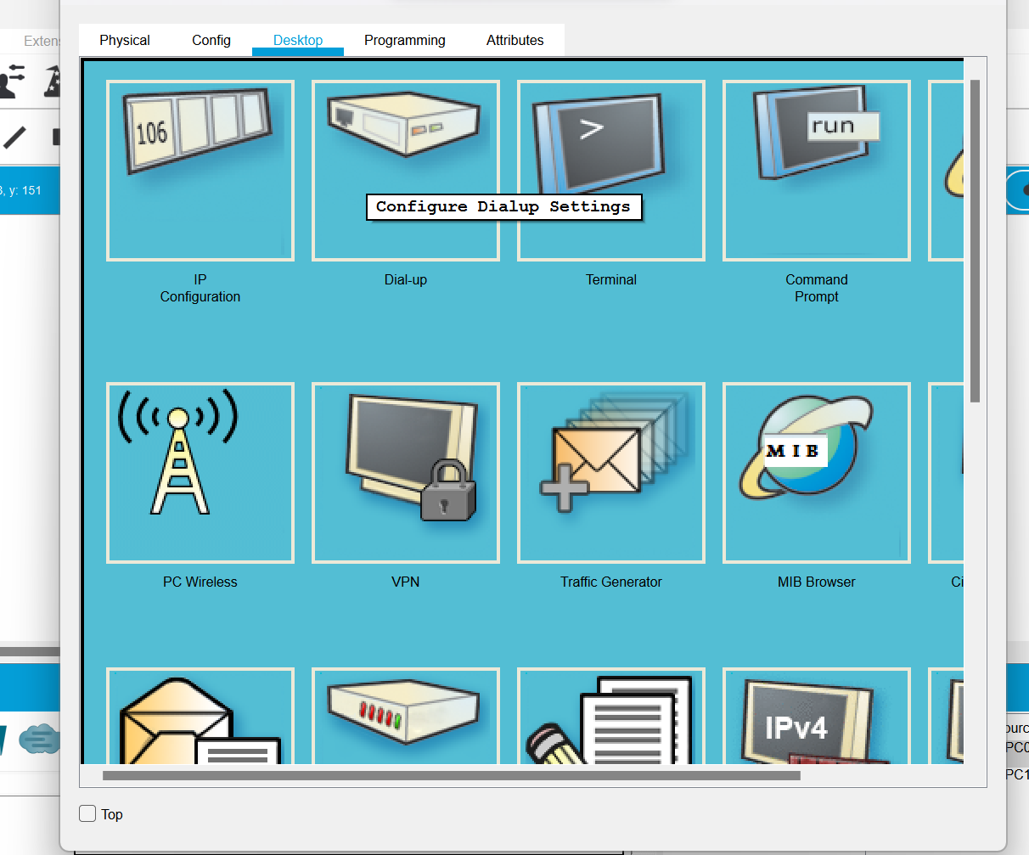

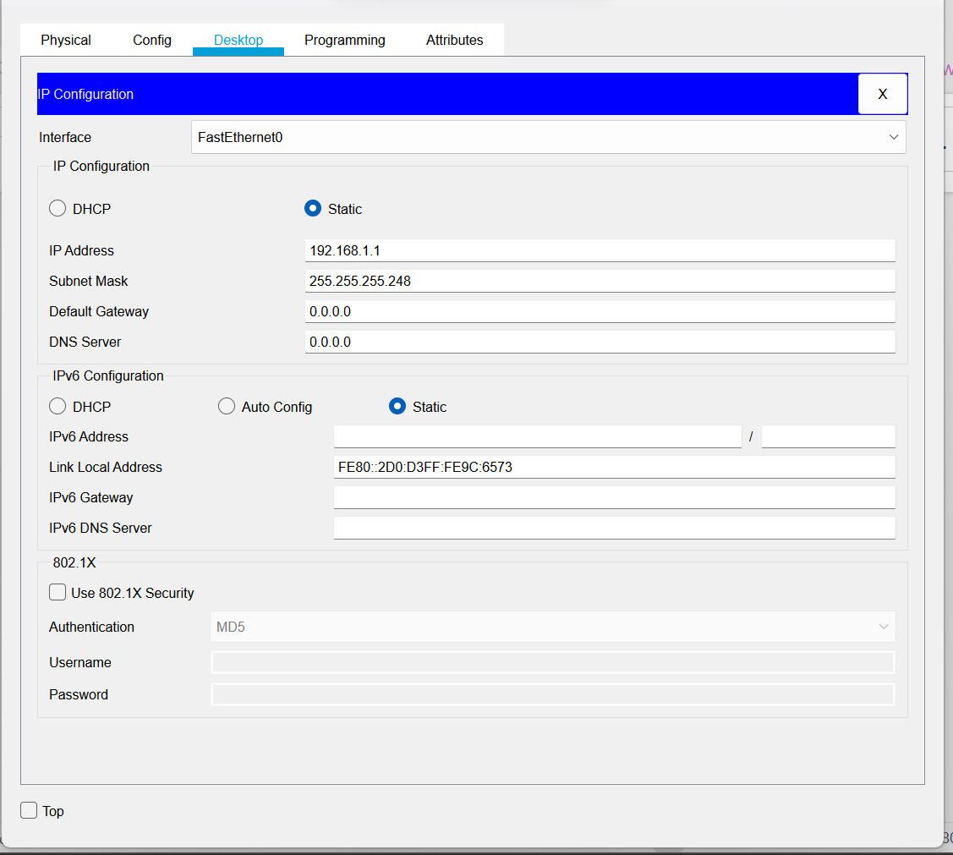

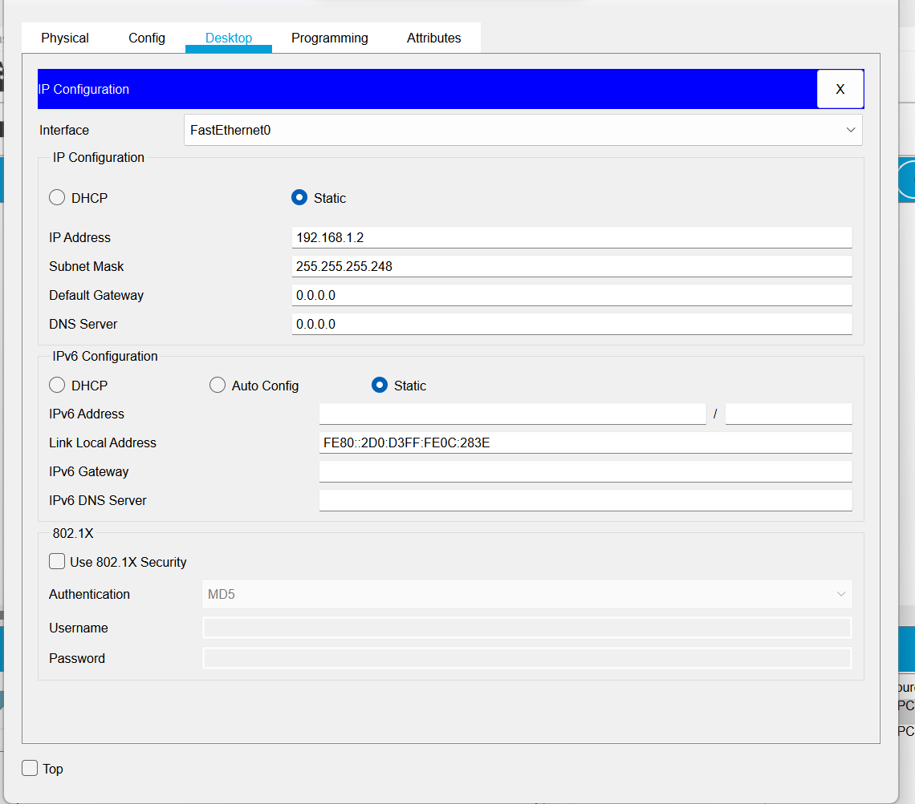

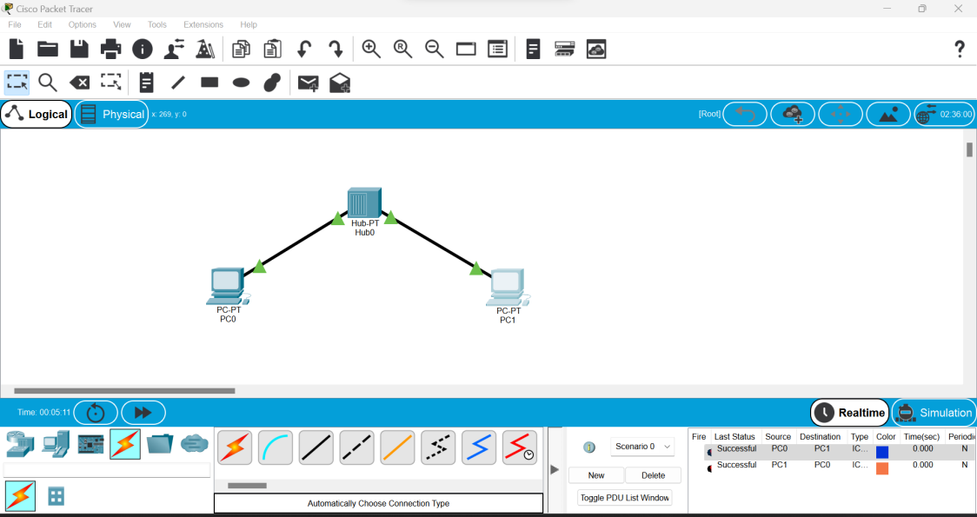

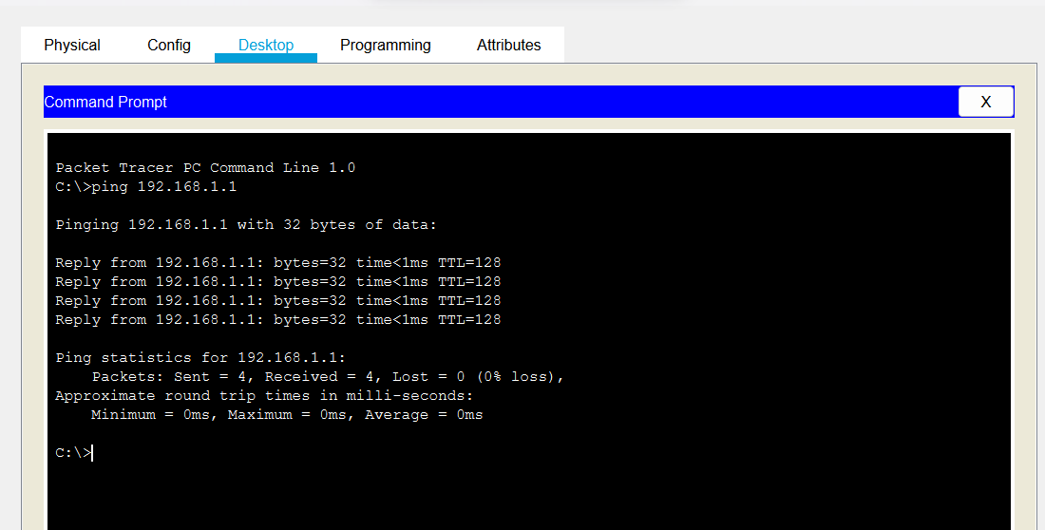

**Switch hub and end devices**

* Start
* Take 3 host/end devices,a hub and a switch for network connection between them
* Connect them using connecting write.
* Configure Ip statically of each end devices
* Enter class-c Ip address at ipv4 and sub-net it(/24)
* Repeat step 3-4 for other end devices
* Pass the message packet from one end devices to other end devices
* Ping any one device IP address using command prompt
* End

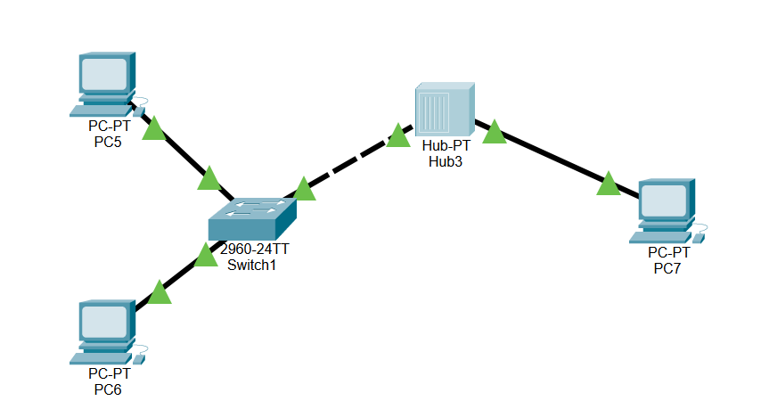

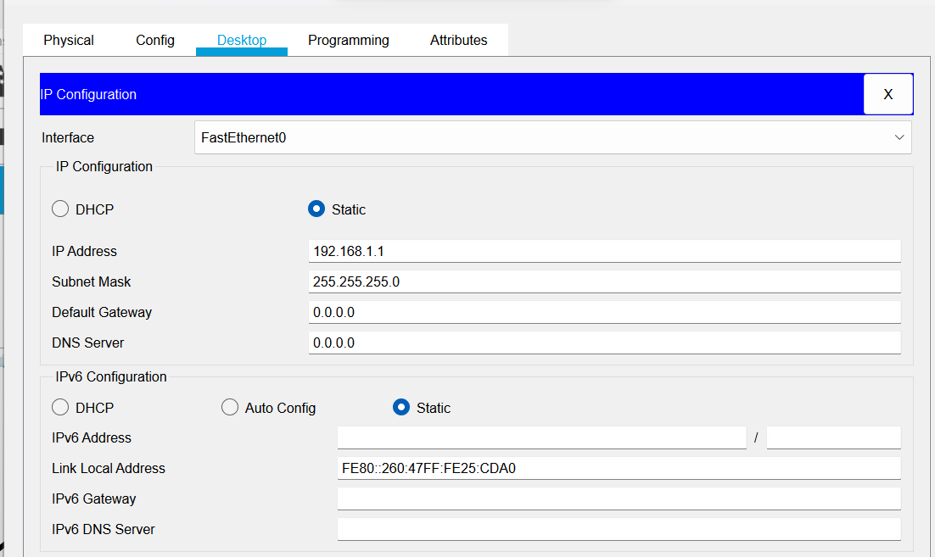

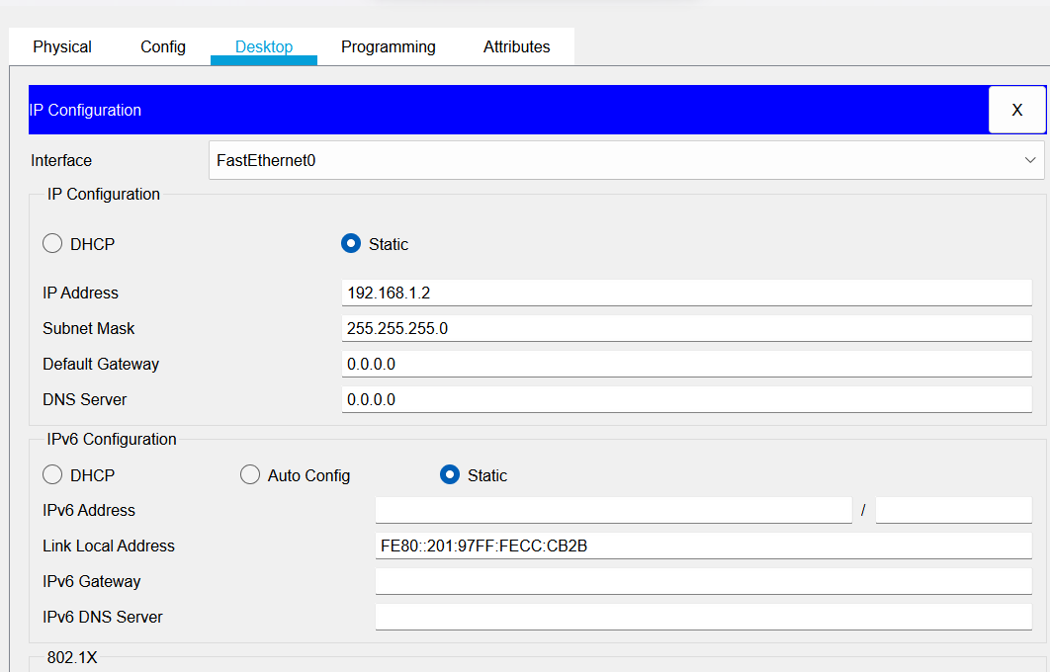

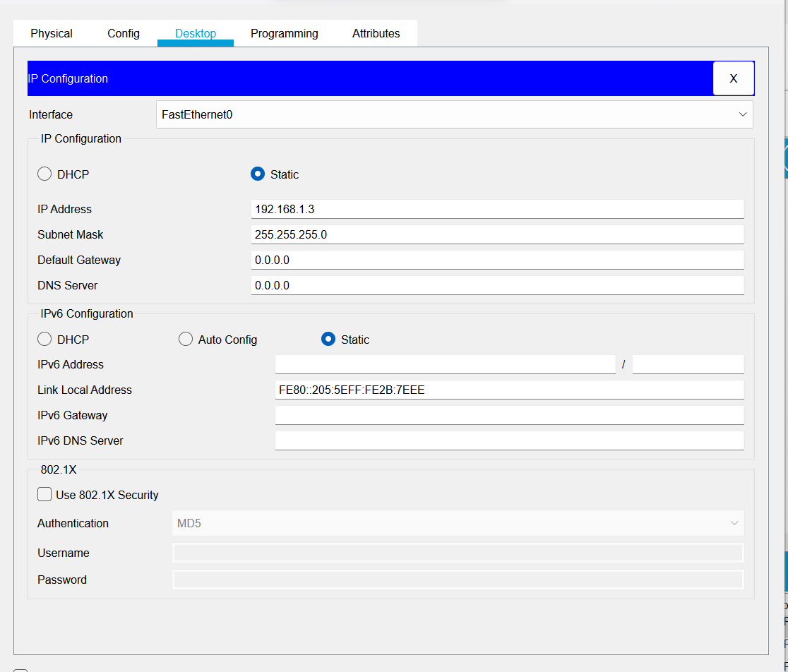

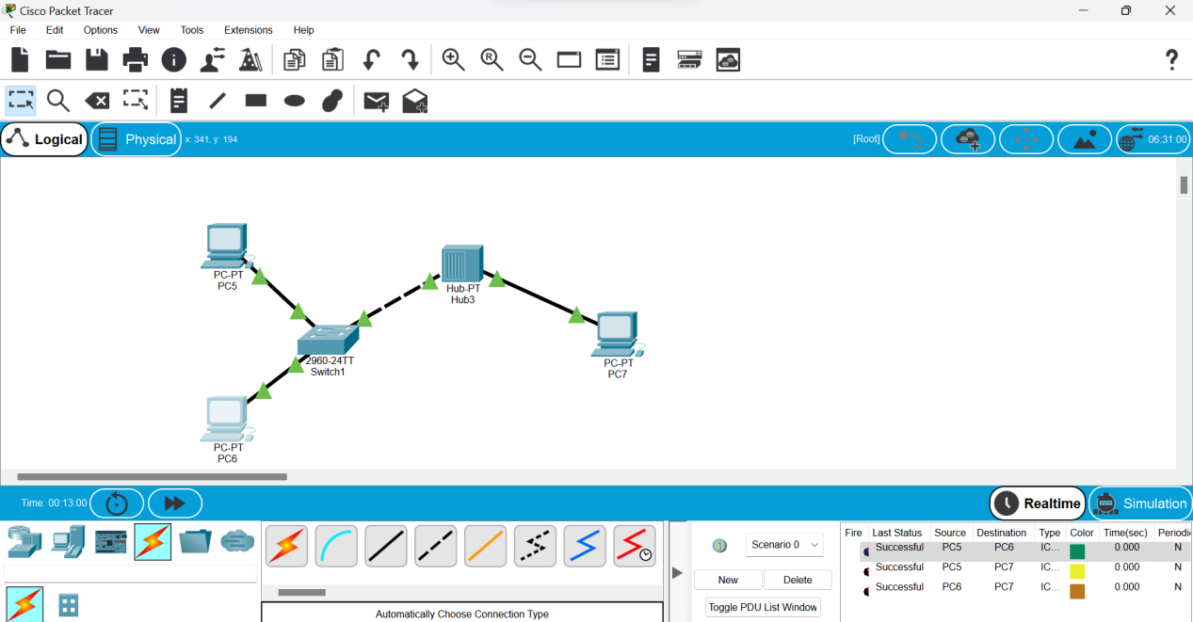

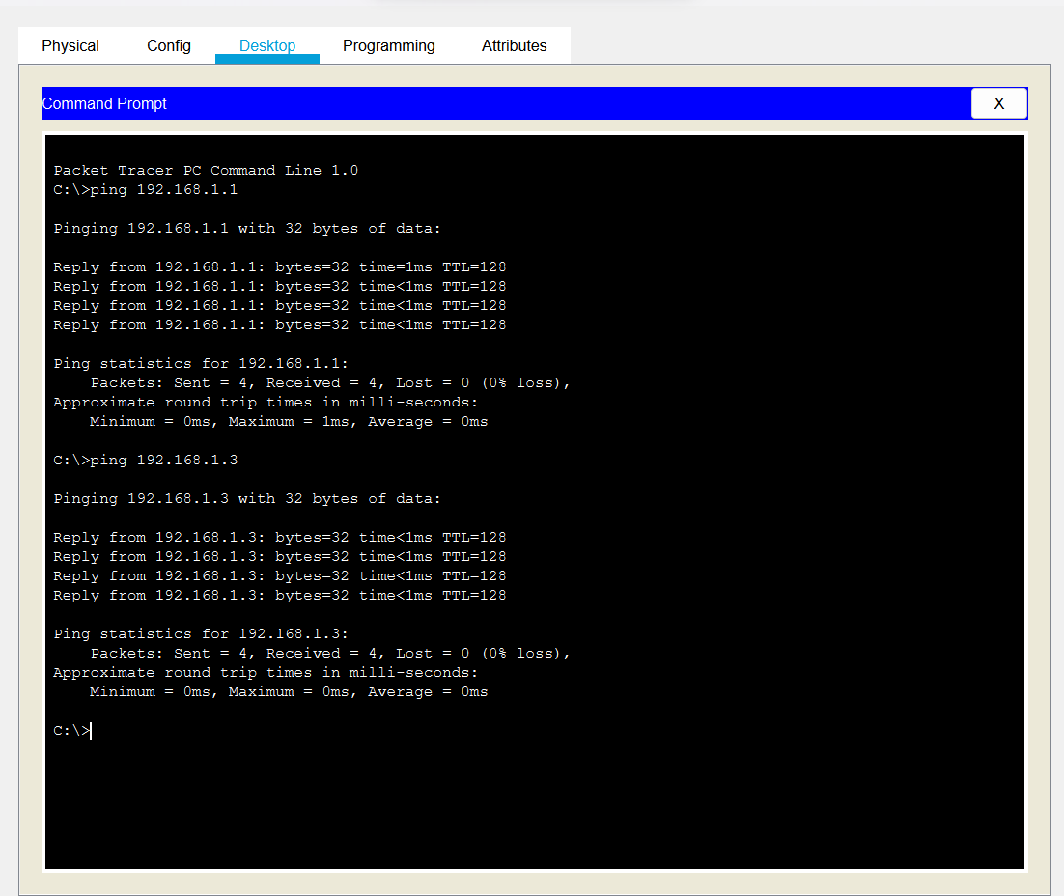

**Server,switch, hub and end devices**

* Start Take 2 Host, a server & a switch for network connection between them.
* Connect them using connection wire.
* Click on server>services>HTTP an make both HTTP and HTTPS on.
* Click on DHCP and turn on services
* Enter the starting IP address and its subnet mask and save it.
* No, server>Desktop and configure the IPv4 address in statically.
* Click on end device>Desktop and turn on DHCP(server will automatically generate the IP address for end device)
* Repeat step 7 for each end device.
* Pass the message packet from one end device to other end device(if it shows successful the design is valid and error less)
* Ping any one device IP address using command prompt
* End

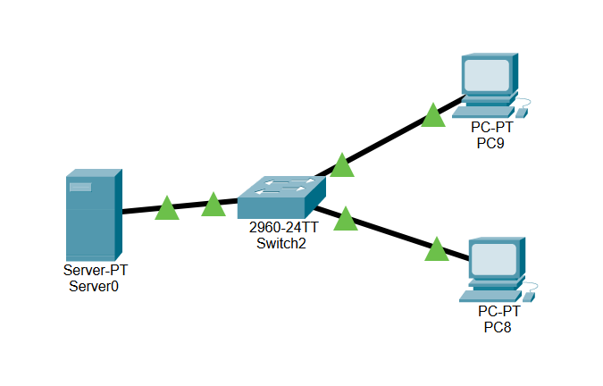

**Server:**

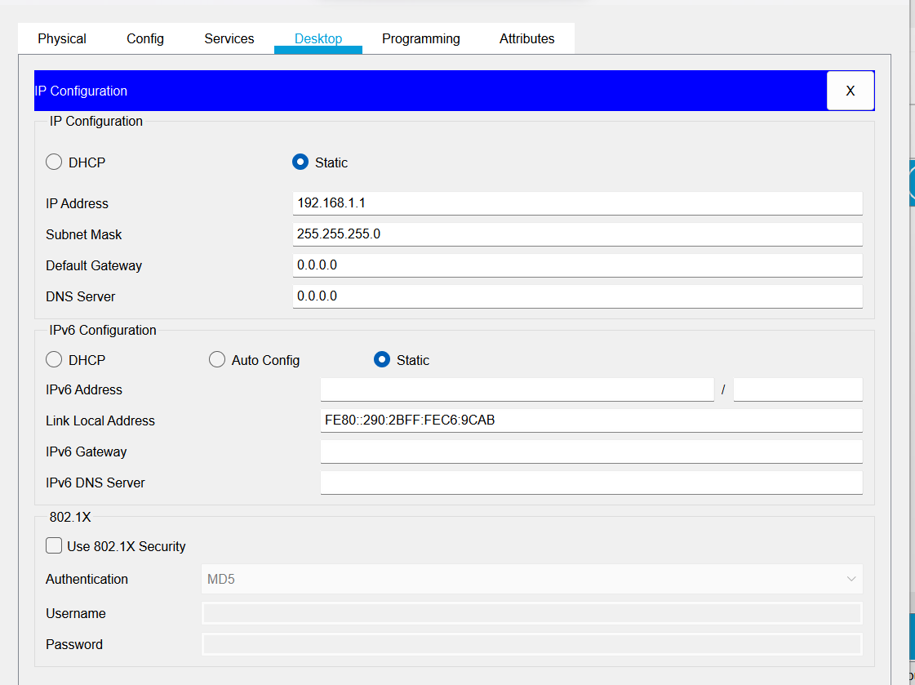

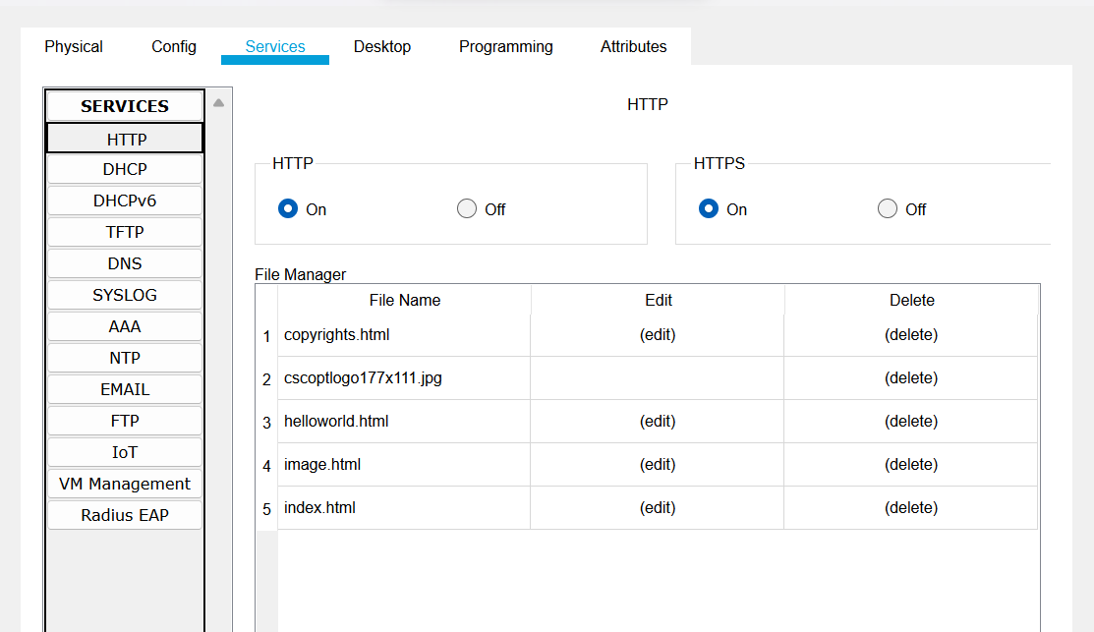

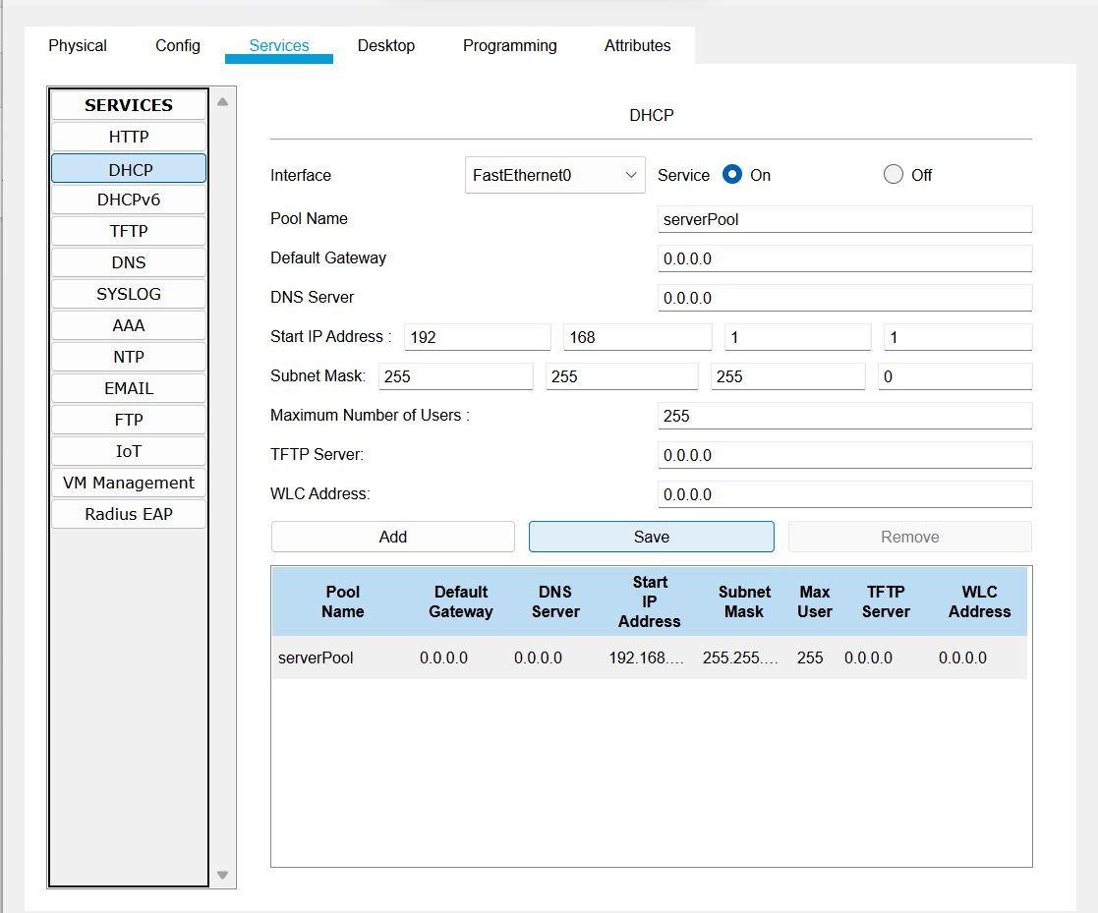

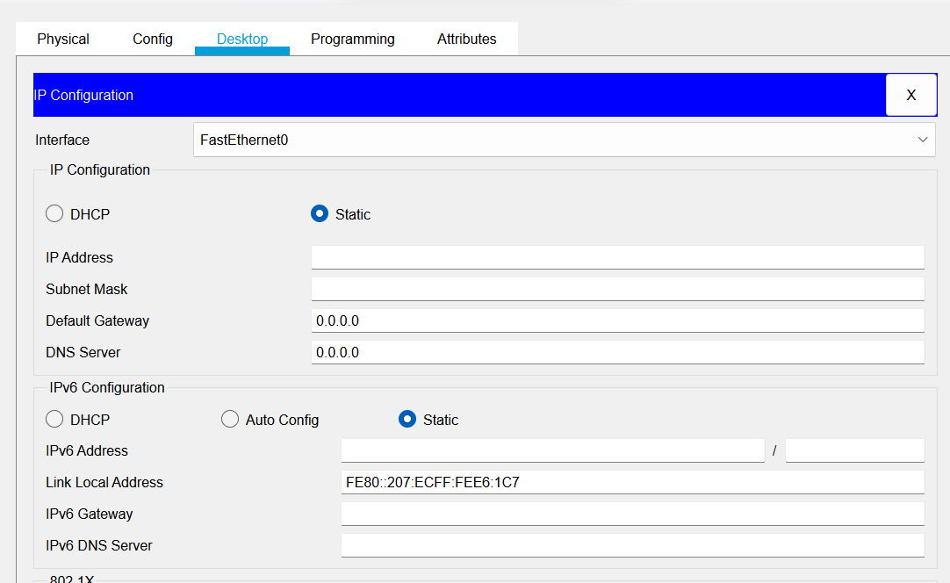

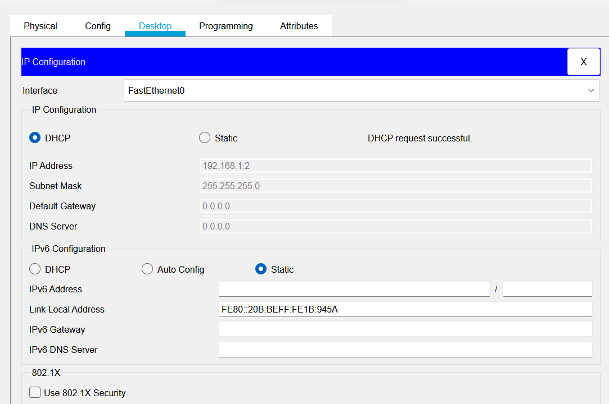

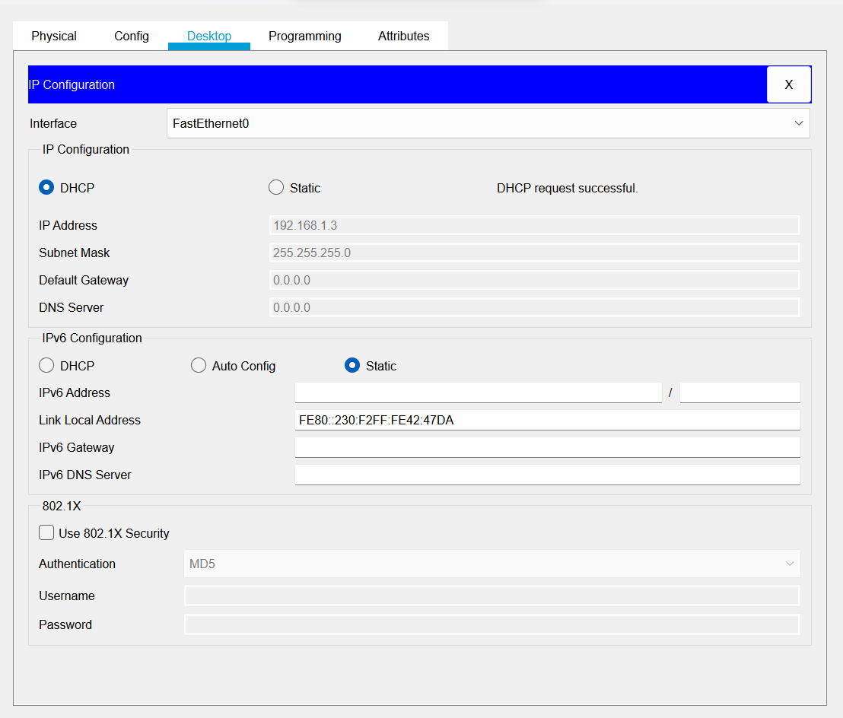

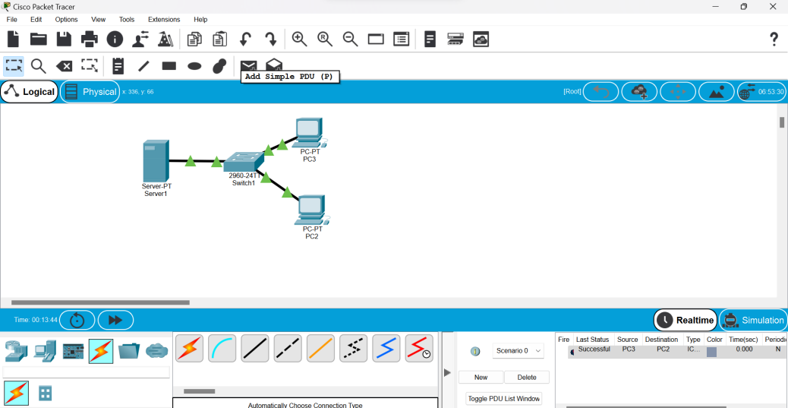

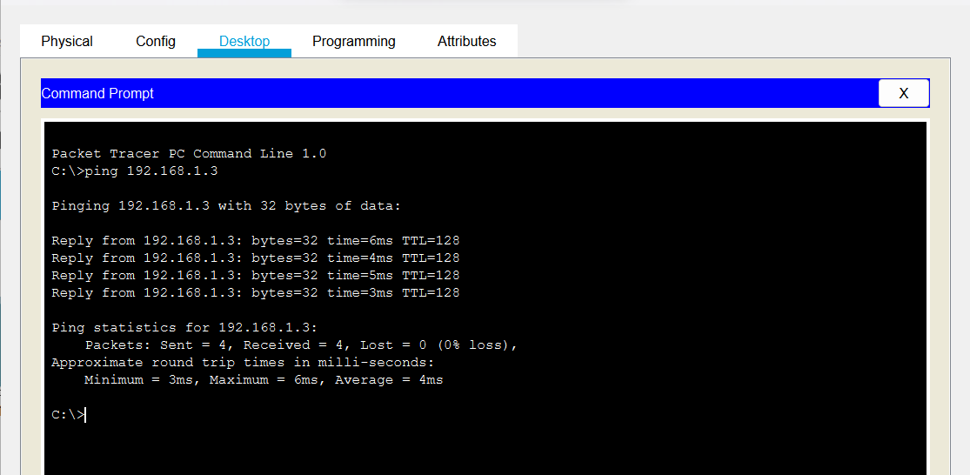

**DNS:**

1. Start
2. Take 1/2 host, a server and a switch for network connection between them.
3. Connect them using connection wire.
4. Click on server>IP configuration and set its IP statically:(192.168.1.1) and give DNS server address:(192.168.1.1)
5. Click on server>services>HTTP and make both HTTP & HTTPs on.
6. Click on edit of index.html and edit its content and save it.
7. Click on DNS and turn it on.
8. Give name:(www.test.com) and DNS server:(192.168.1.1)
9. Give static IP address to hosts and give the same DNS server:(192.168.1.1)
10. Click on host>desktop>web browser and search with DNS name/server i.e. (www.test.com)/(192.168.1.1)
11. End

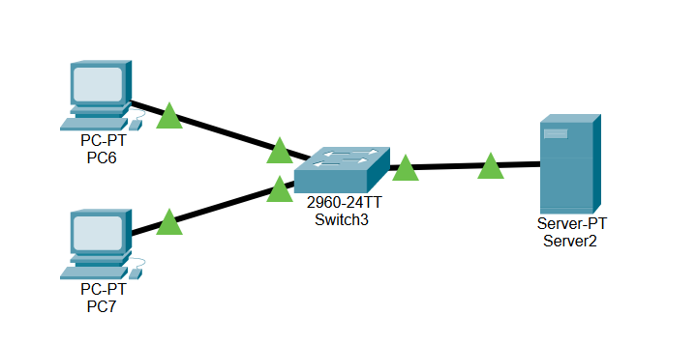

Server:

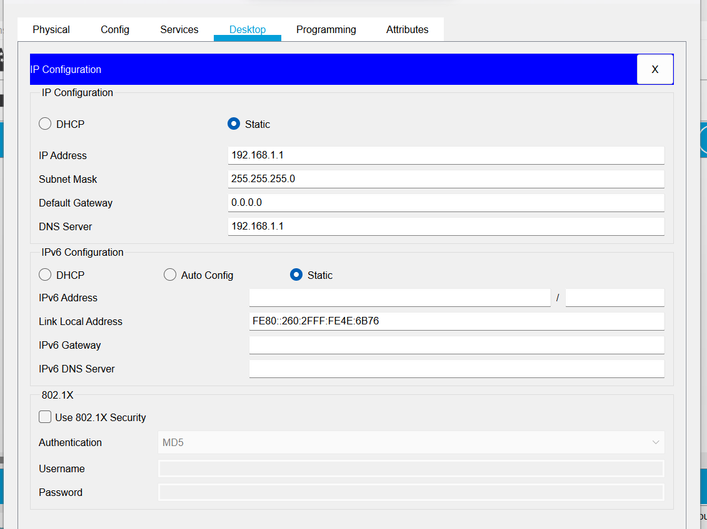

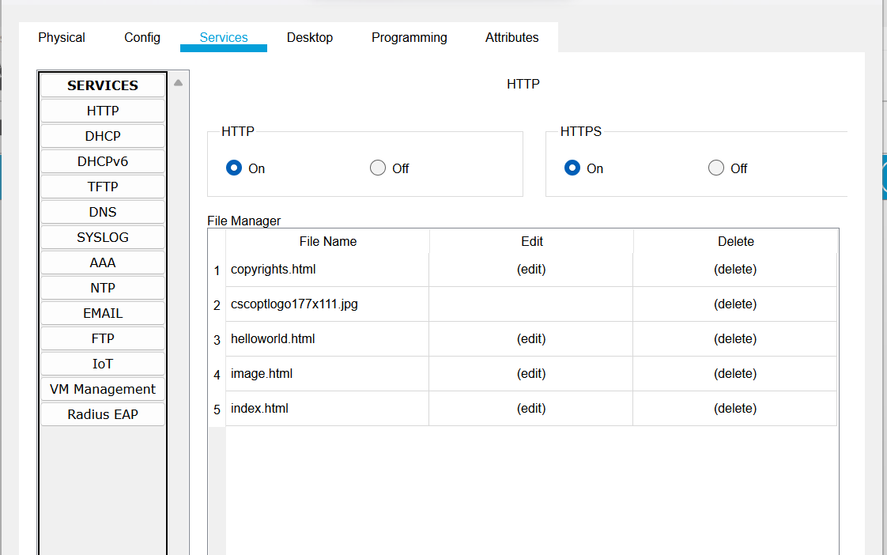

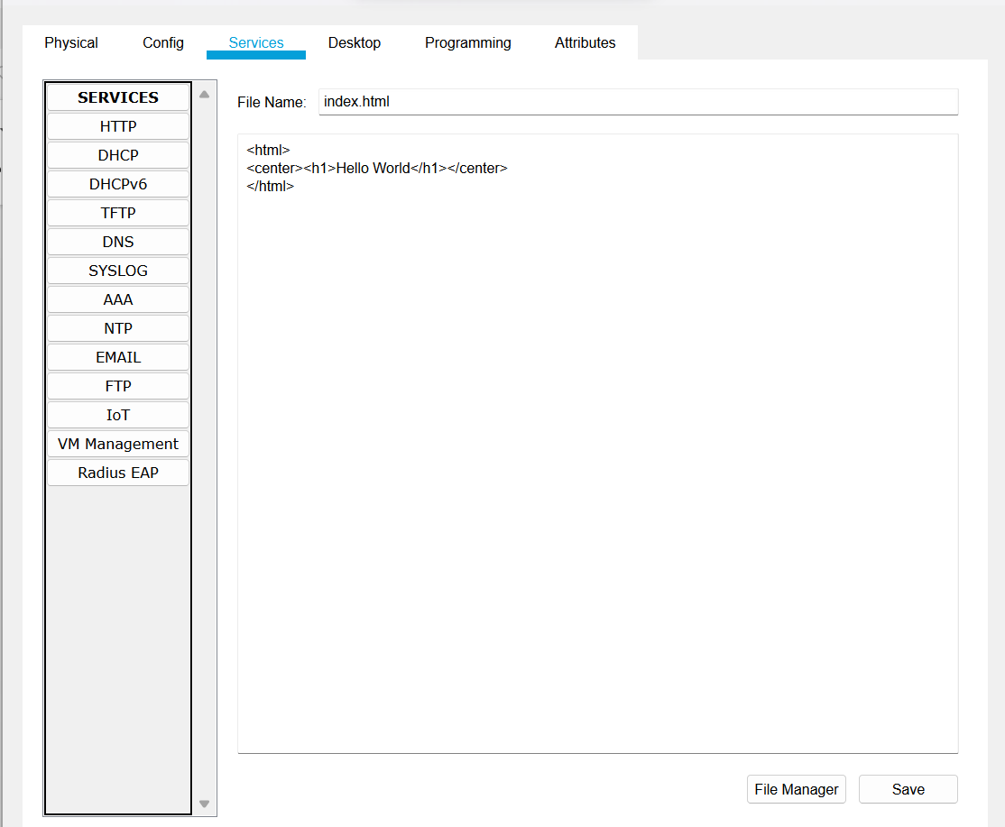

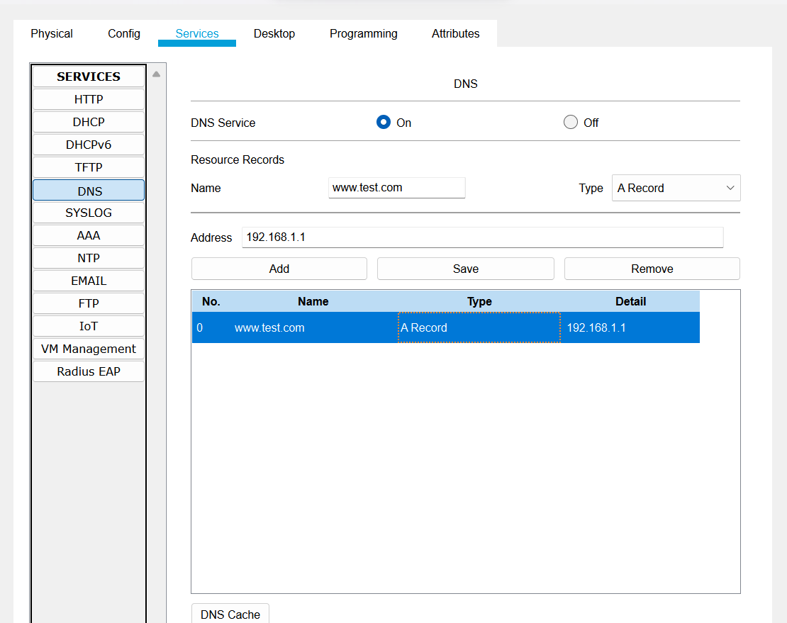

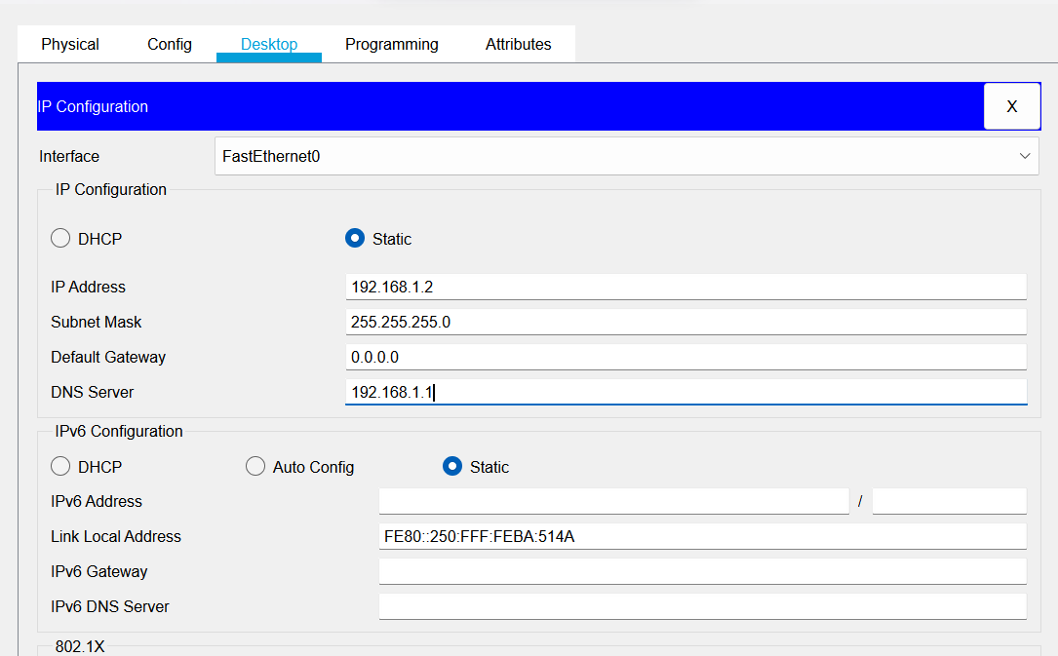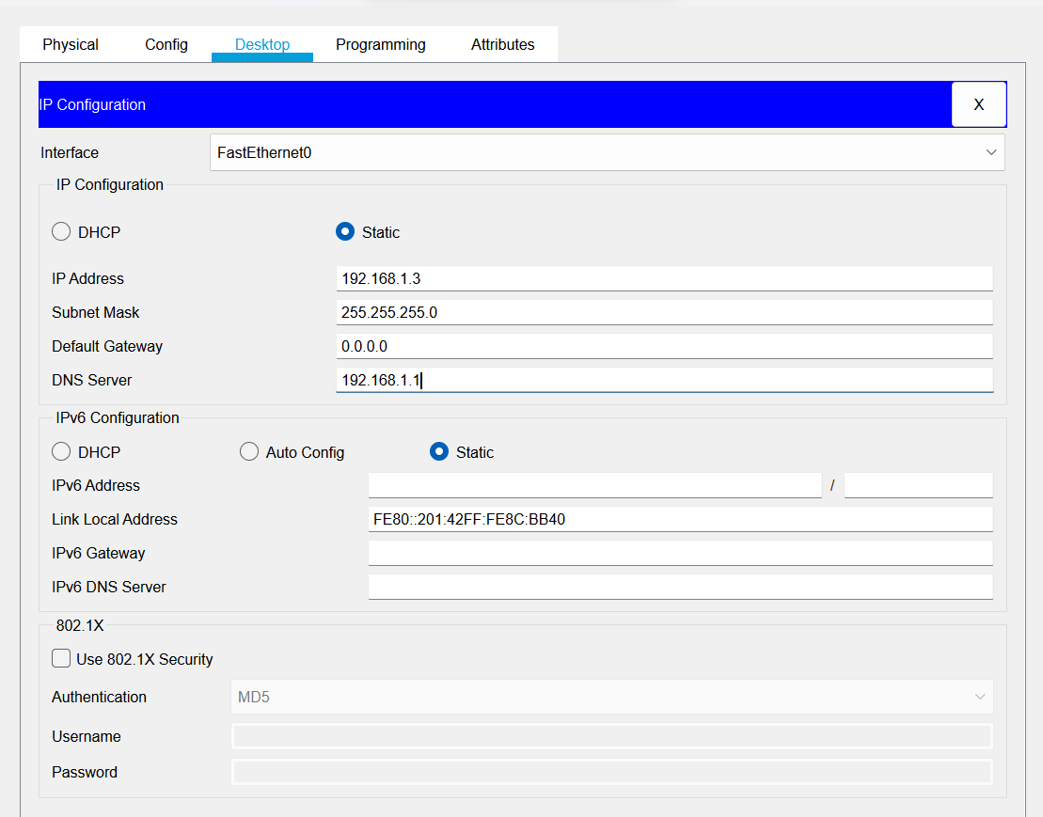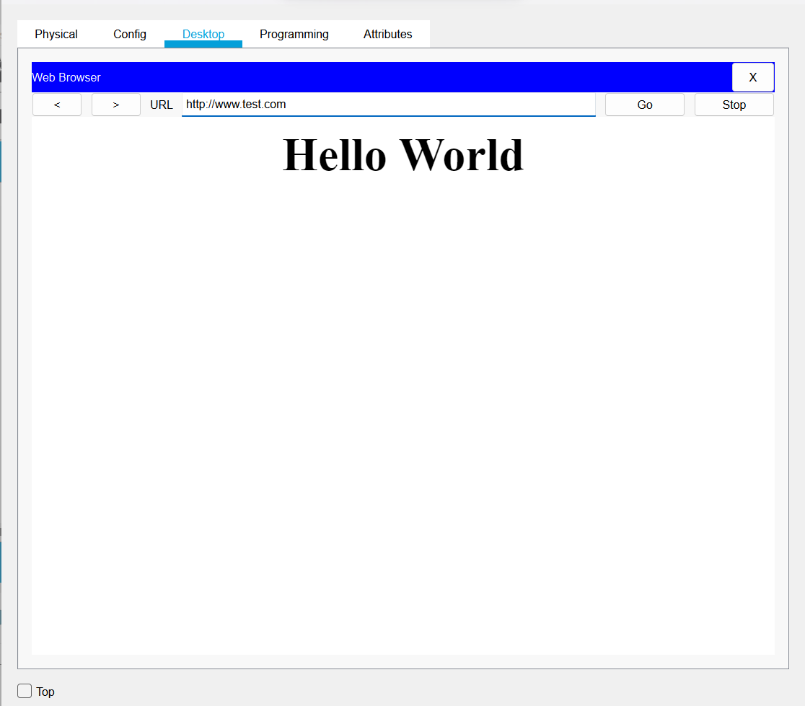

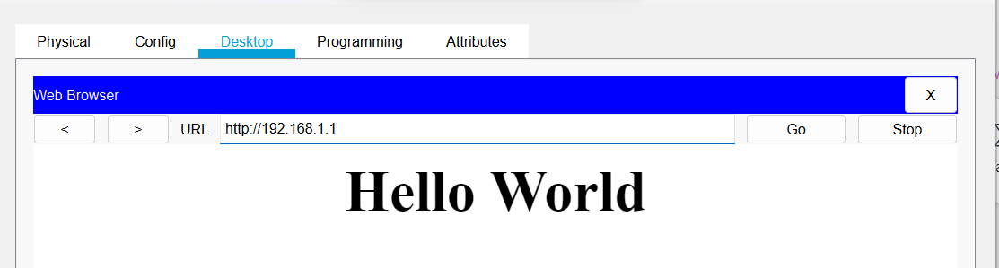

**DNS& DHCP server :**

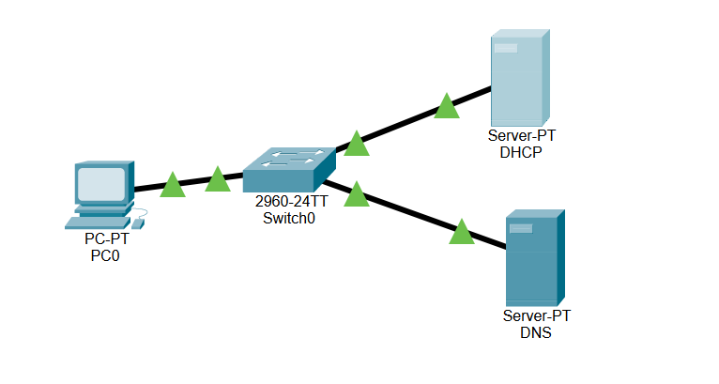

DNS:

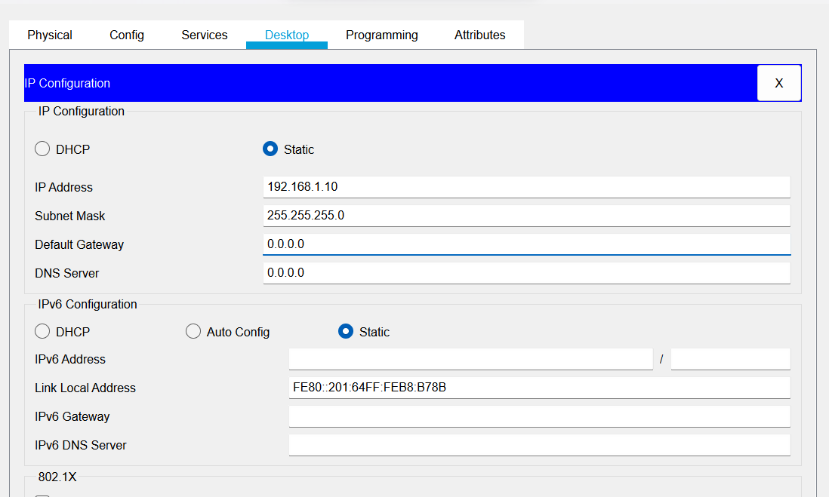

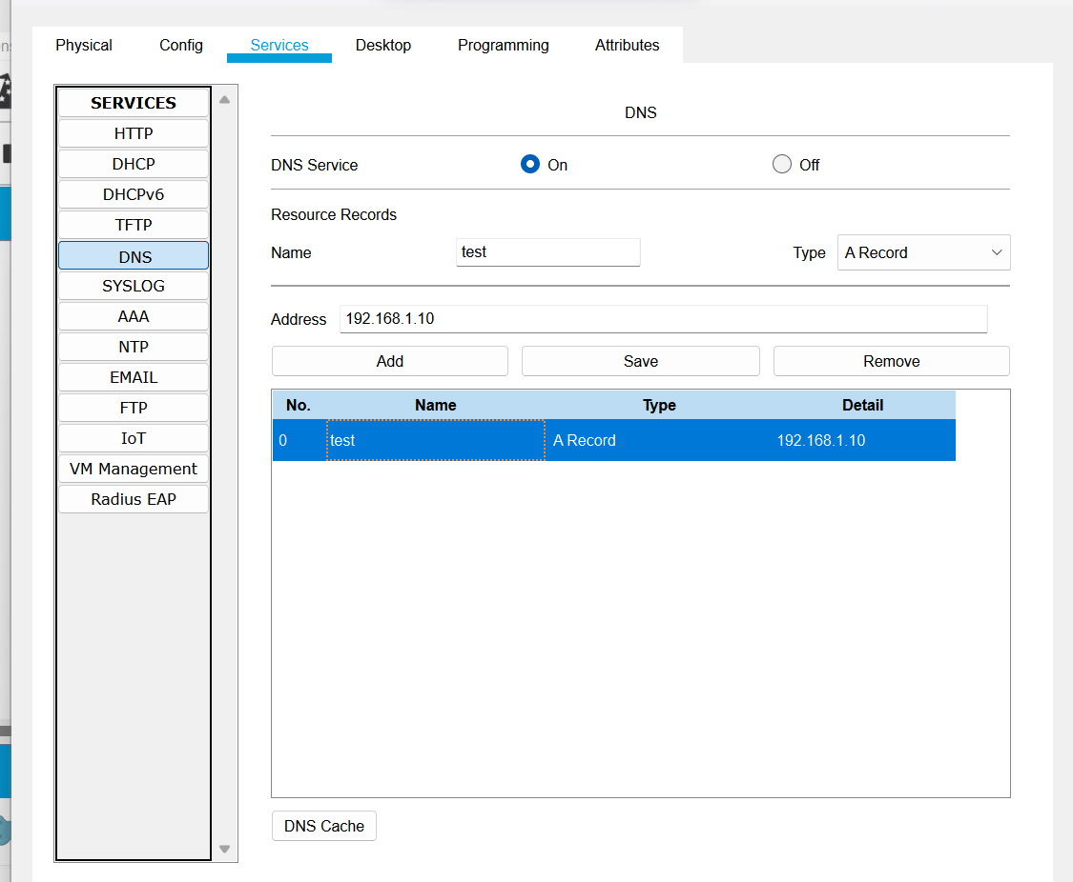

DHCP:

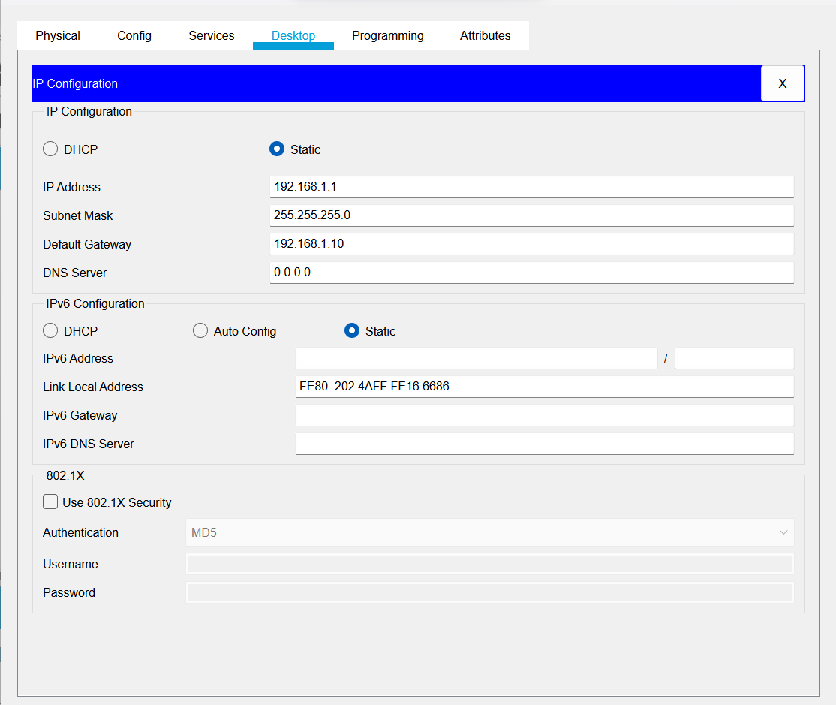

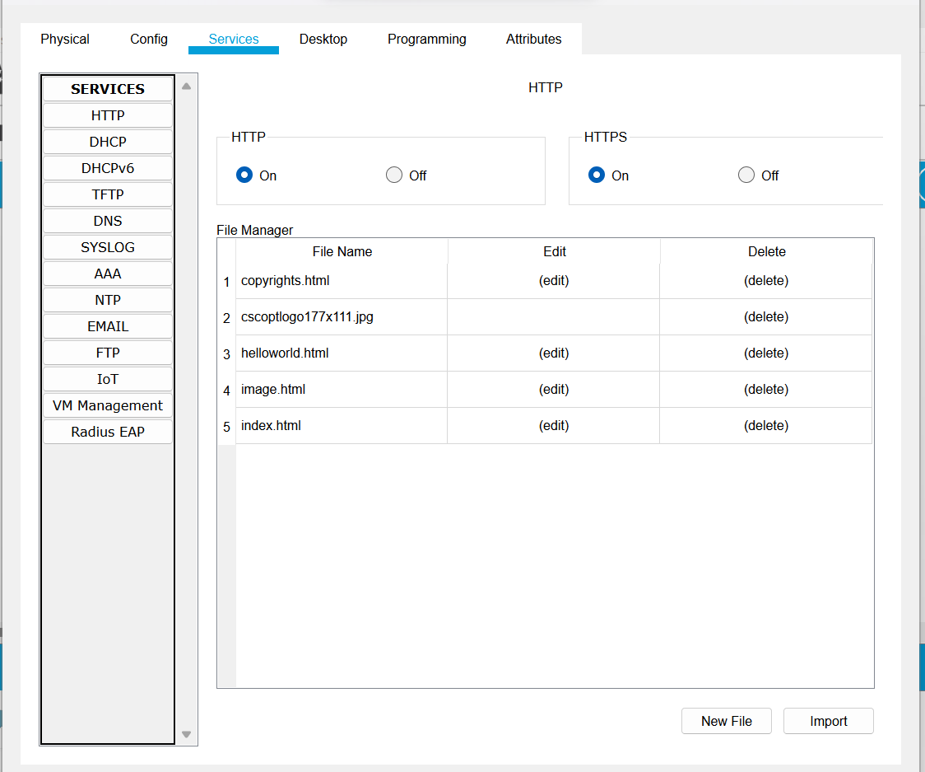

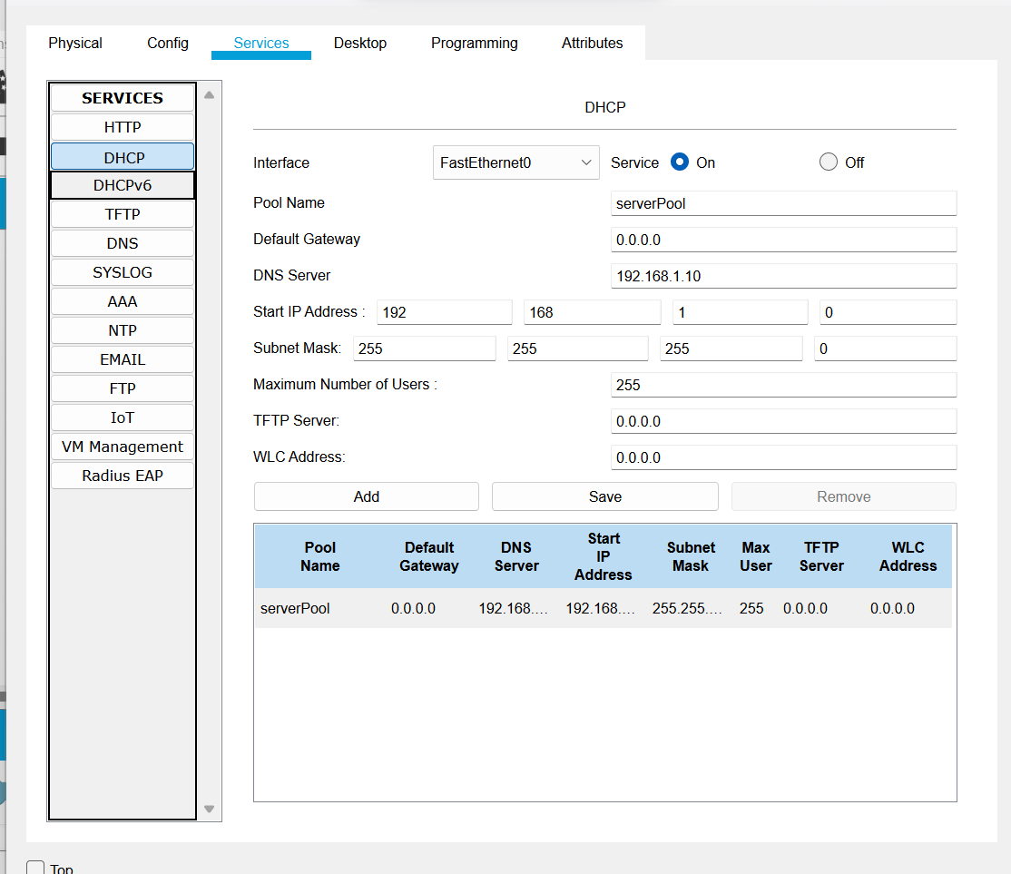

PC:

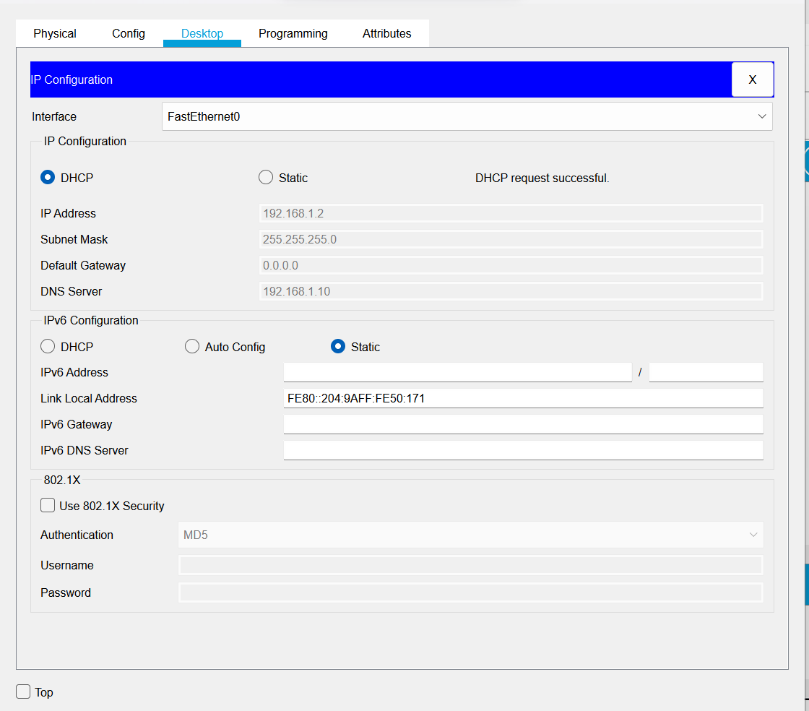

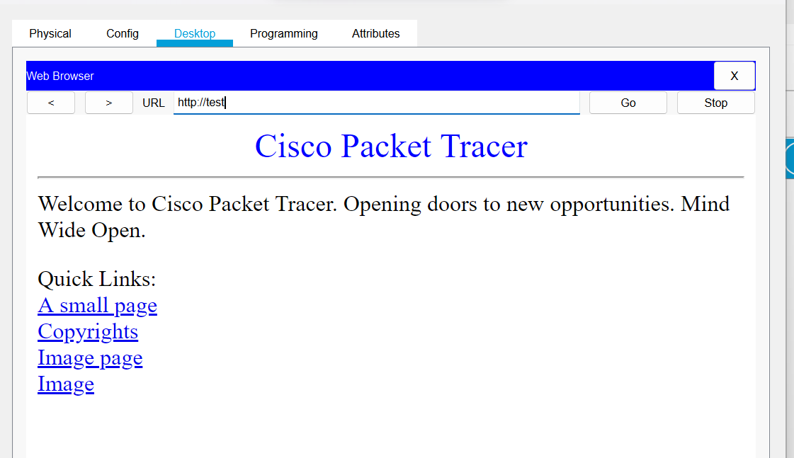

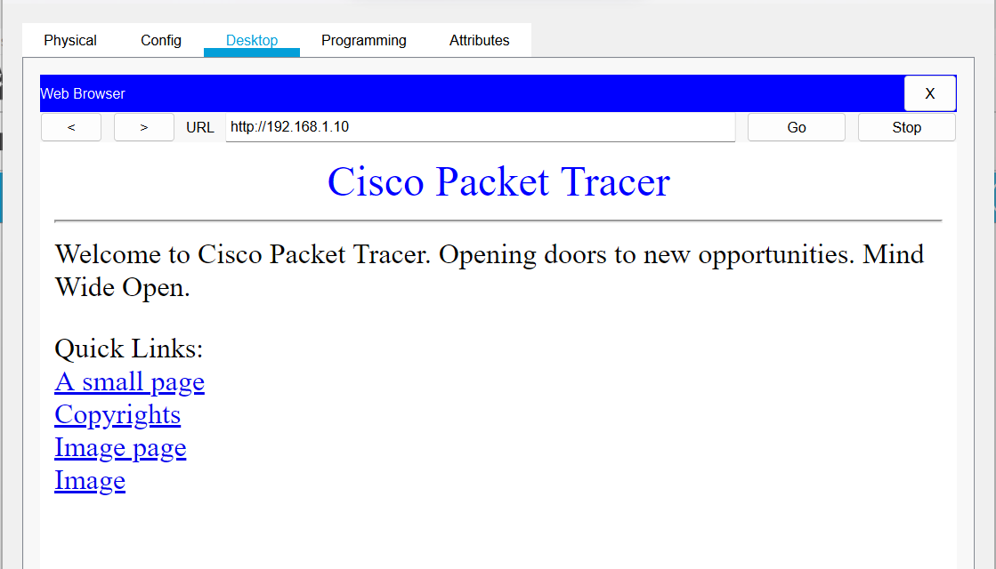

**Router:**

* Start
* Take 4 host, 2 switch and a router for network connection between them
* Connect them using connection wire
* Give each host IP address of class c and subnet them & default gateway
* Click router>Interface>GigabitEthernet 0/0 and set IP which was default gateway
* Click GigabitEthernet 0/1 and set IP which was default gateway
* Pass the message packet from one end device to other and from end device to router
* Perform ping test
* End

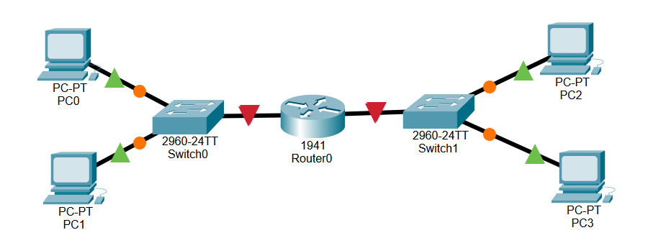

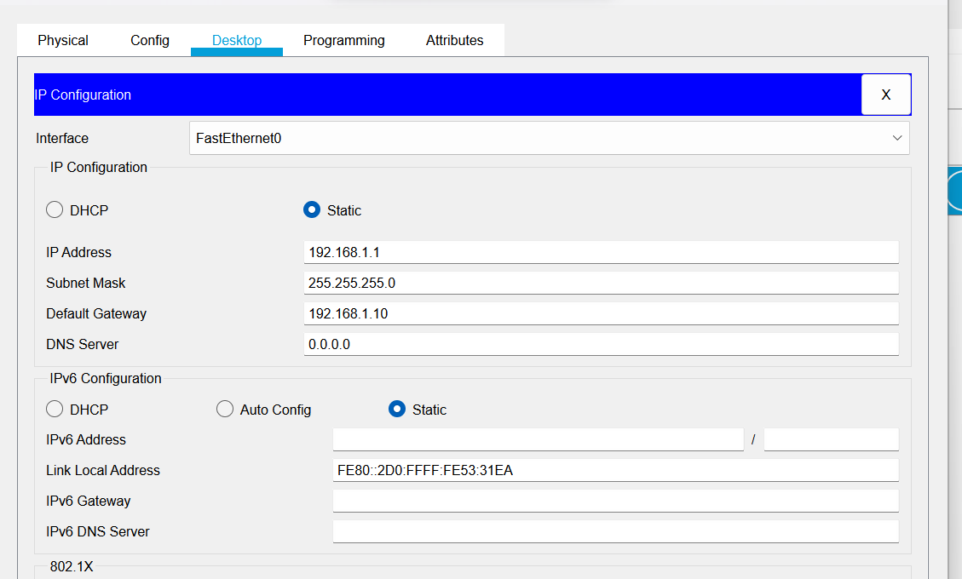

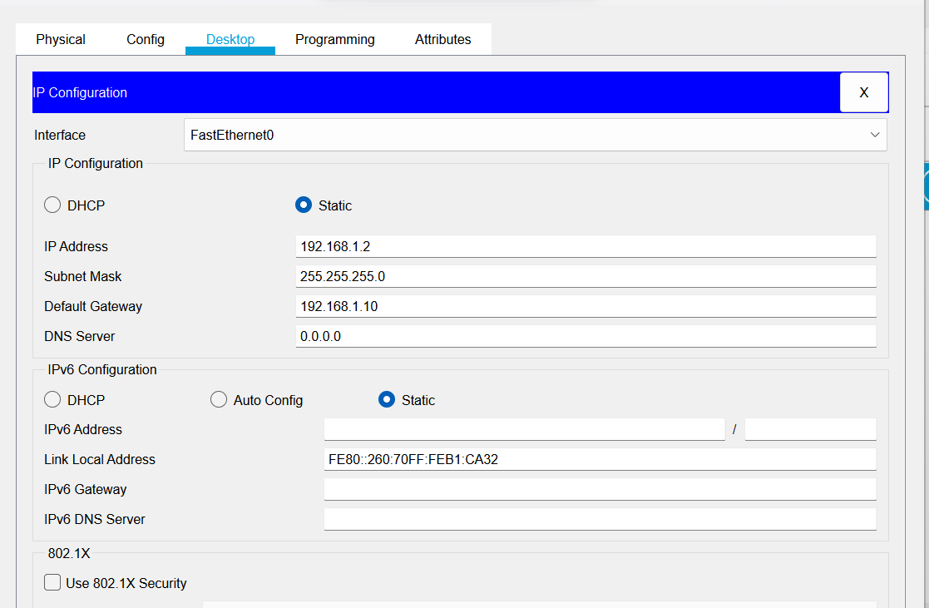

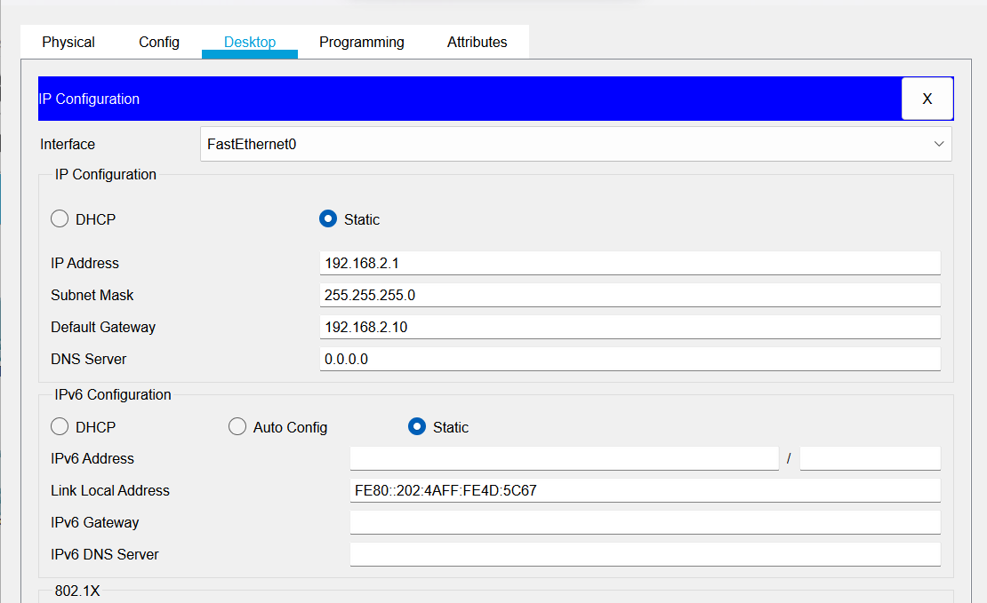

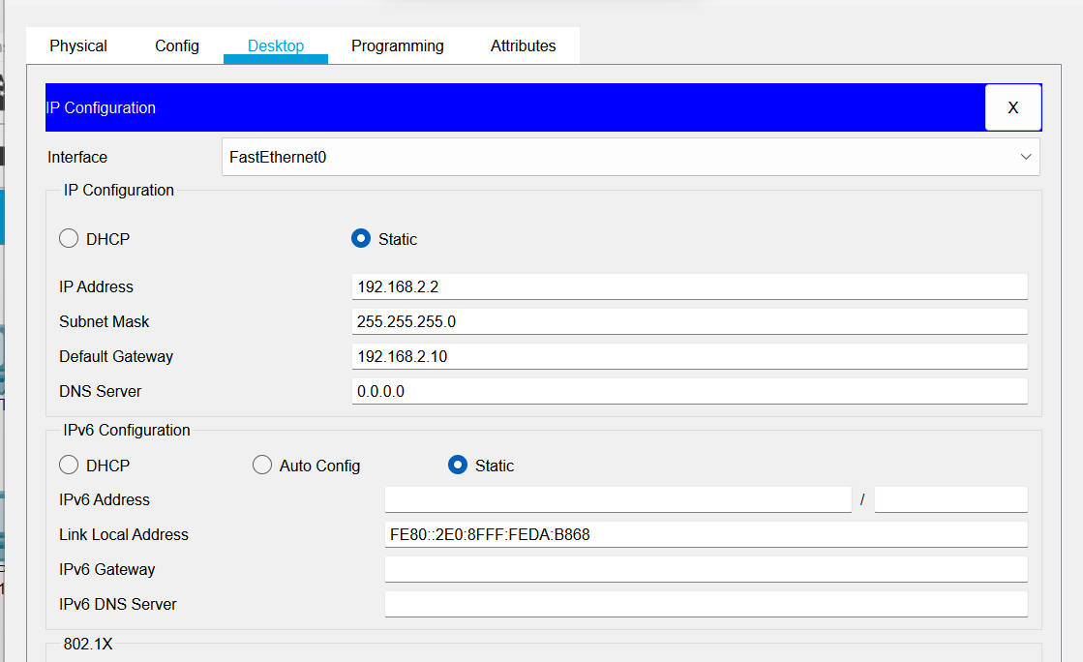

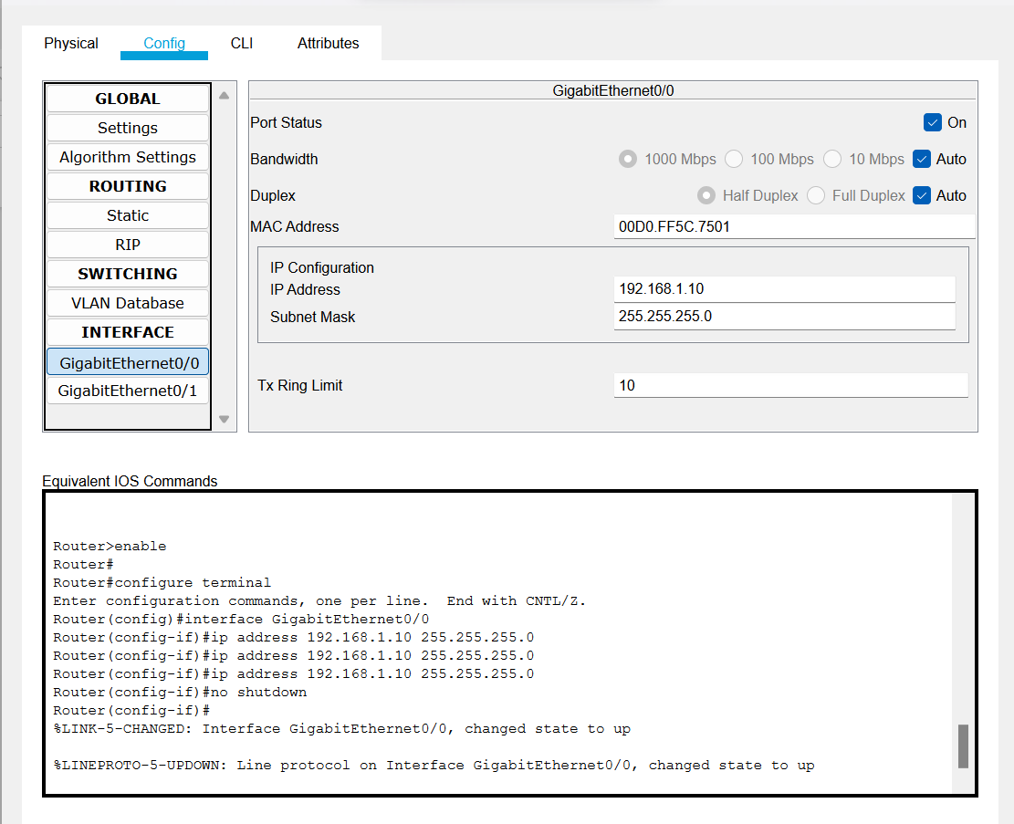

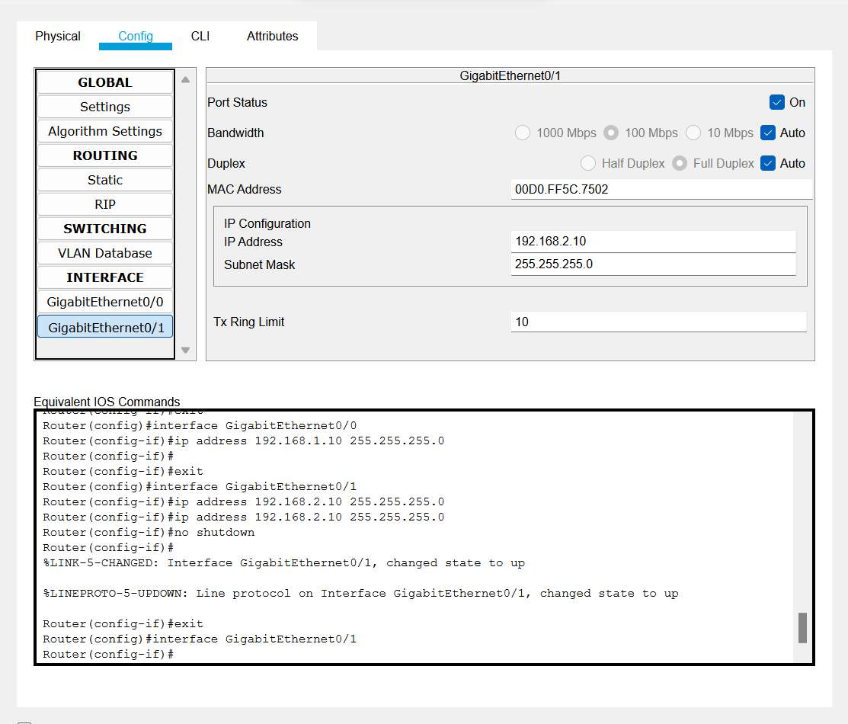

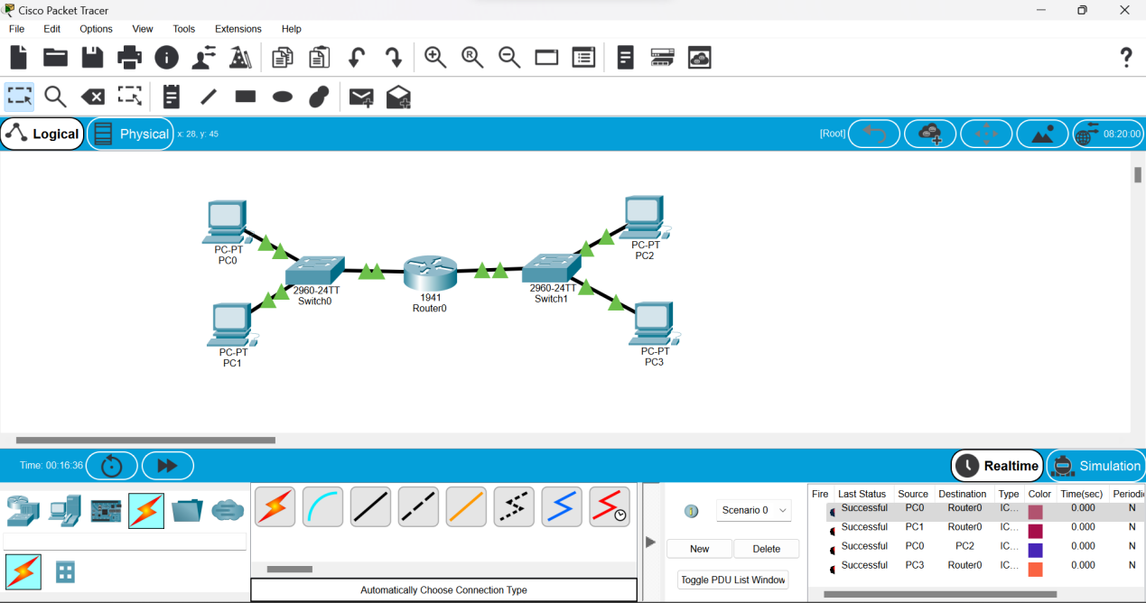

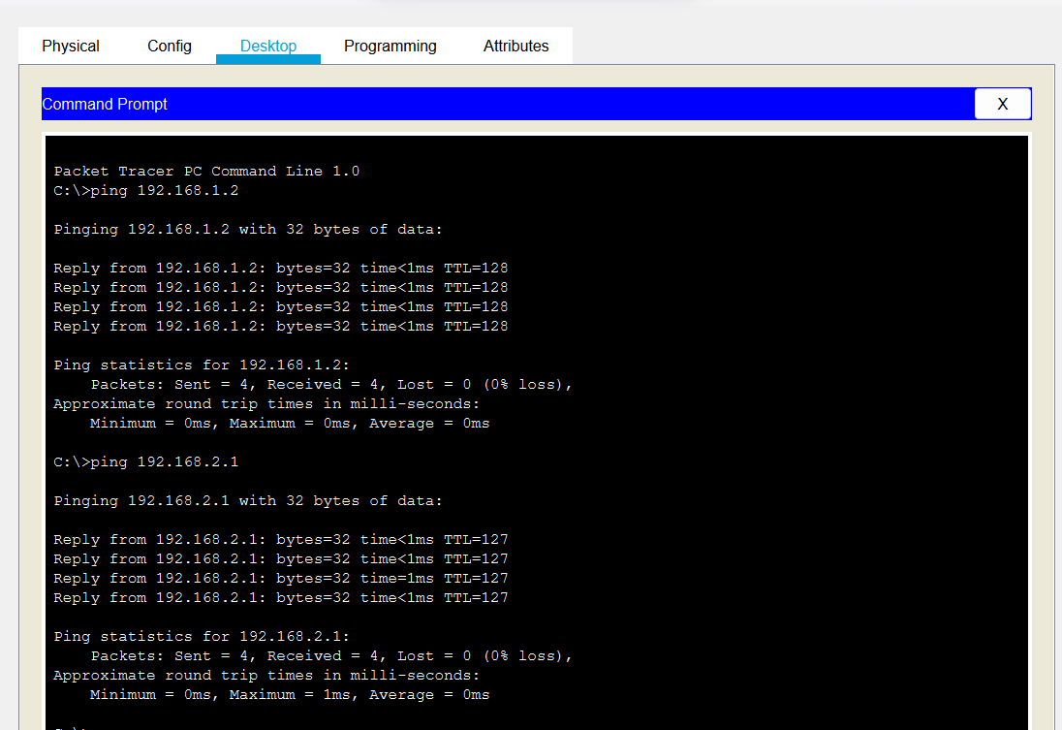

**Wireless Connection:**

